Press release 2017

FOR IMMEDIATE RELEASE

GRAFF Introduces SADE Collection
Faucets with Modern Lines Set to Impress

Drawing upon clean, modern lines and the latest technology, GRAFF's SADE Collection, provides a simplistic, yet comprehensive range of articles both deck and wall mounted, with a single lever or as a widespread set, for the bathroom and for the shower. Designed internally by the celebrated G+ Design Studio, the collection navigates contemporary concepts and geometric silhouettes, delivering a fixture that speaks to GRAFF's long-held reputation for cutting-edge manufacturing and design capabilities.
The faucet plays on the strengths of minimalist design motifs, as evidenced by the curved, flat spout. The handles’ gentle curve recalls the spout’s inclination, enriching the faucet’s charm and refined character, while its hallmark shape emulates old world fountains that distribute water with grace.

The faucet’s spout is constructed with a solid brass block (emptied internally), granting a thicker silhouette with unique, eye-catching proportions. SADE is manufactured in brass, with a very low nickel and lead content, in compliance with all drinking water regulations and the most restrictive criteria required for the protection of health and the environment.

The Sade collection is available in the PC (polished chrome) and SN (Steelnox®), the special satin nickel finish patented by GRAFF that is 100% fingerprint-resistant. Obtained through a galvanic process and subsequent powder coating treatment, the SN finishing stands out for its originality and prolonged resistance over time.

Per informazioni e immagini in alta risoluzione

Ufficio Stampa:
tac comunic@zione milano|genova
tel +39 02 48517618 | 0185 351616
press@taconline.it | www.taconline.it

GRAFF EUROPE
Via Aretina 159, 50136 Florence - ITALY
Tel: +39 055 9332115,
fax: +39 055 9332116
email: info@graff-mixers.com
www.graff-faucets.com

Attached images:

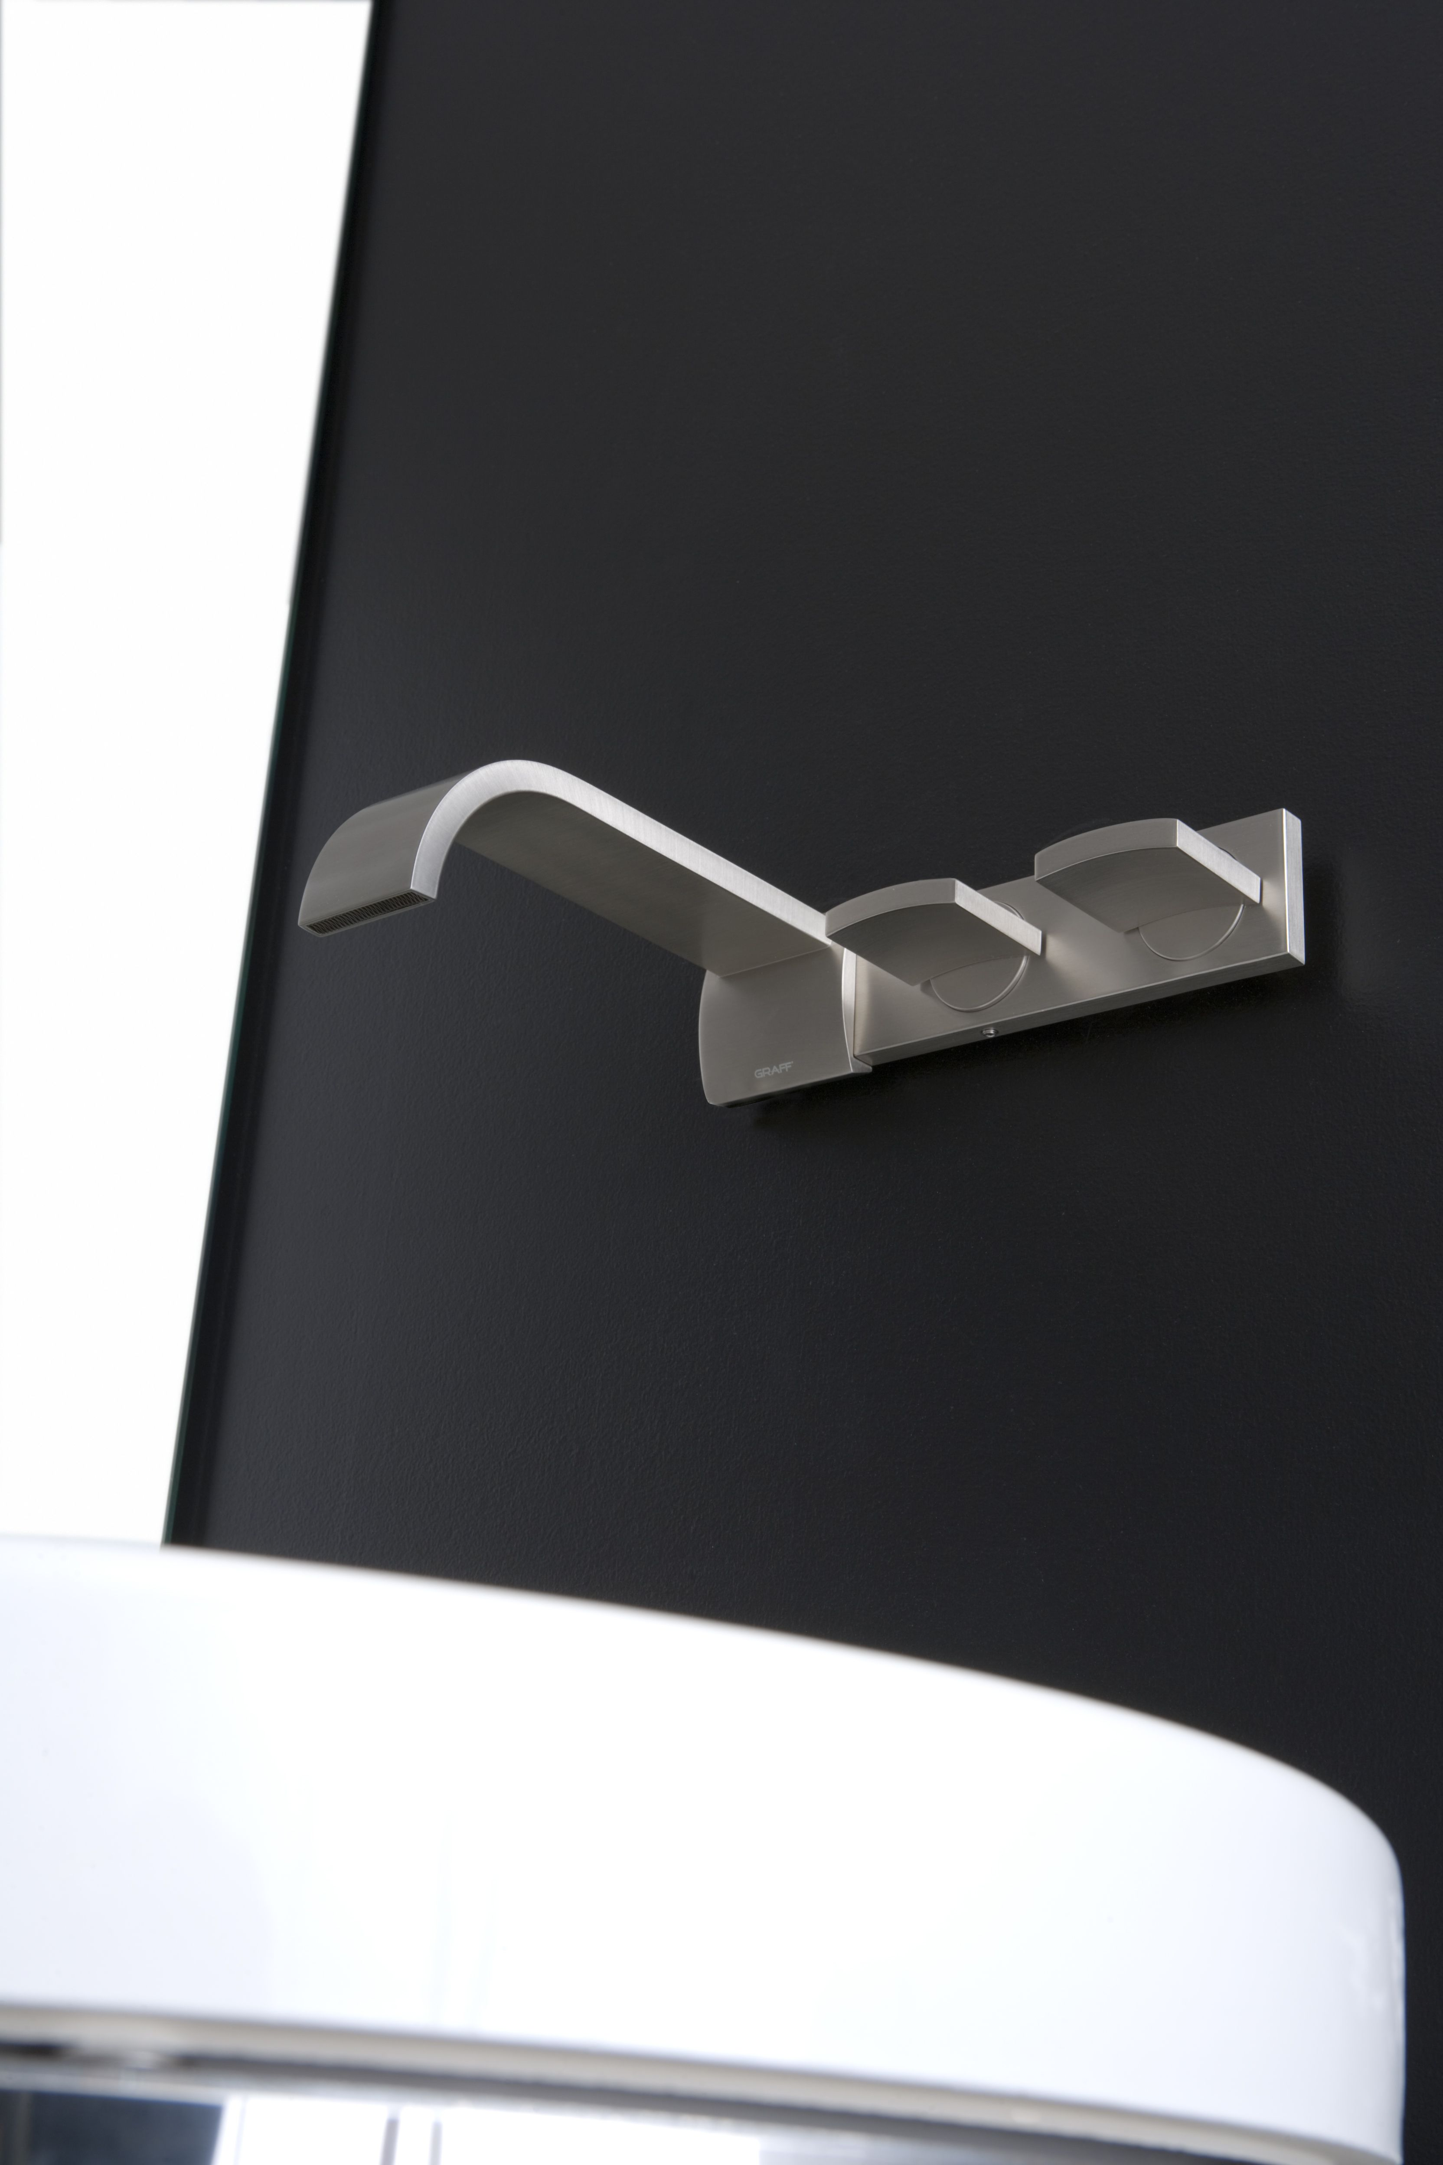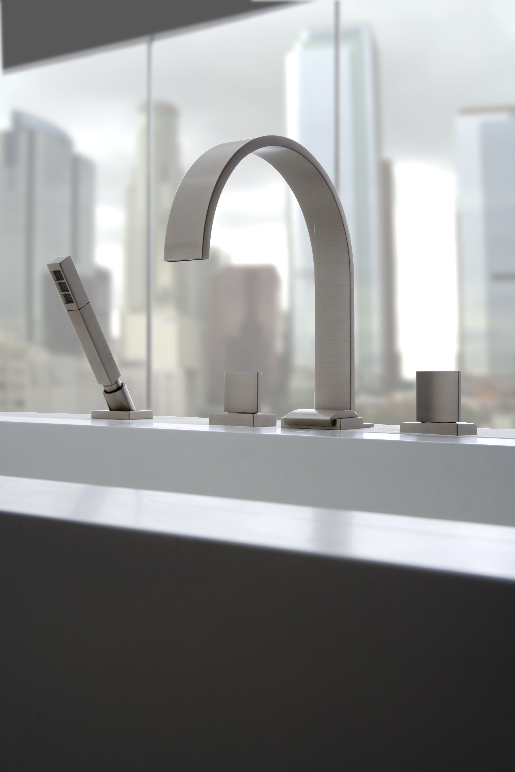

Wall-mounted Washbasin Mixers in Steelnox® finish (SN),
Widespread deck-mounted bathtub set in Steelnox® finish (SN).

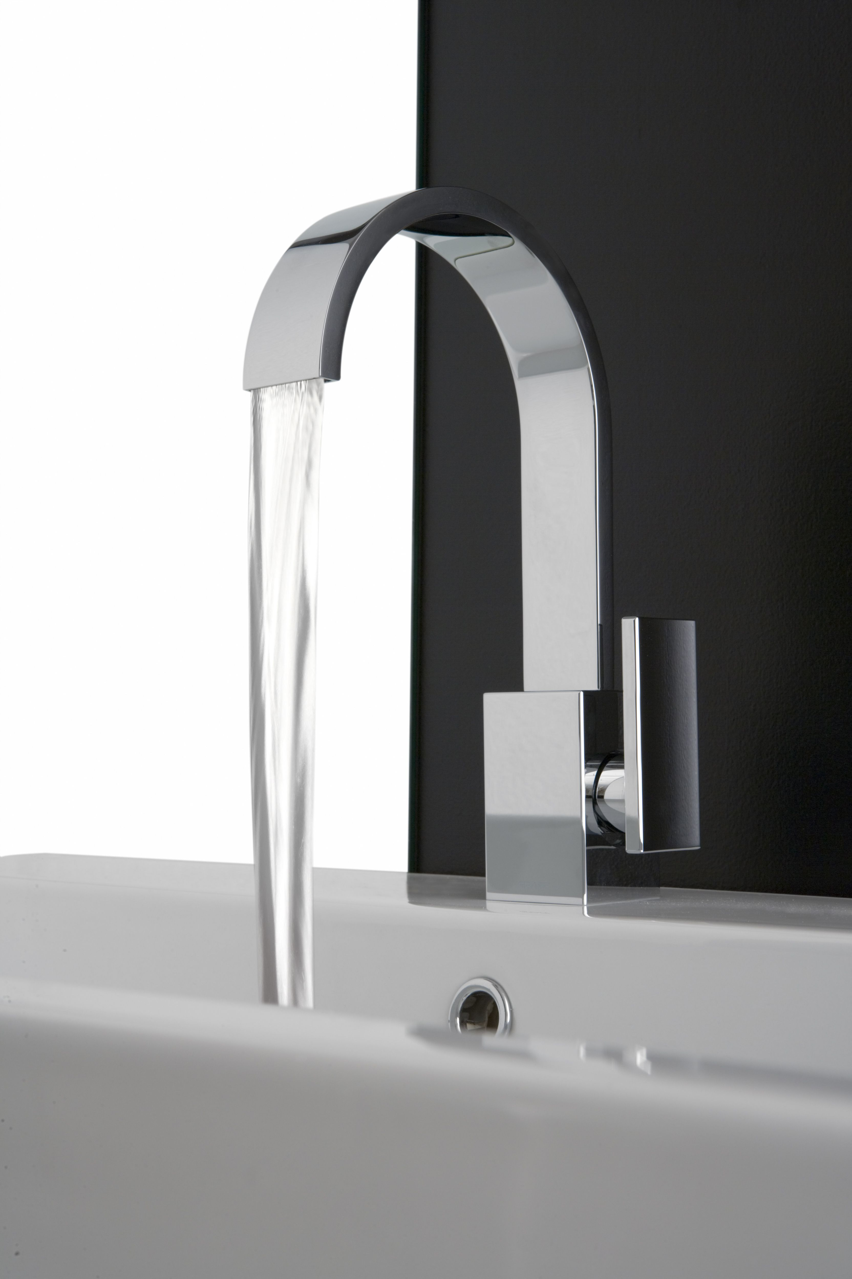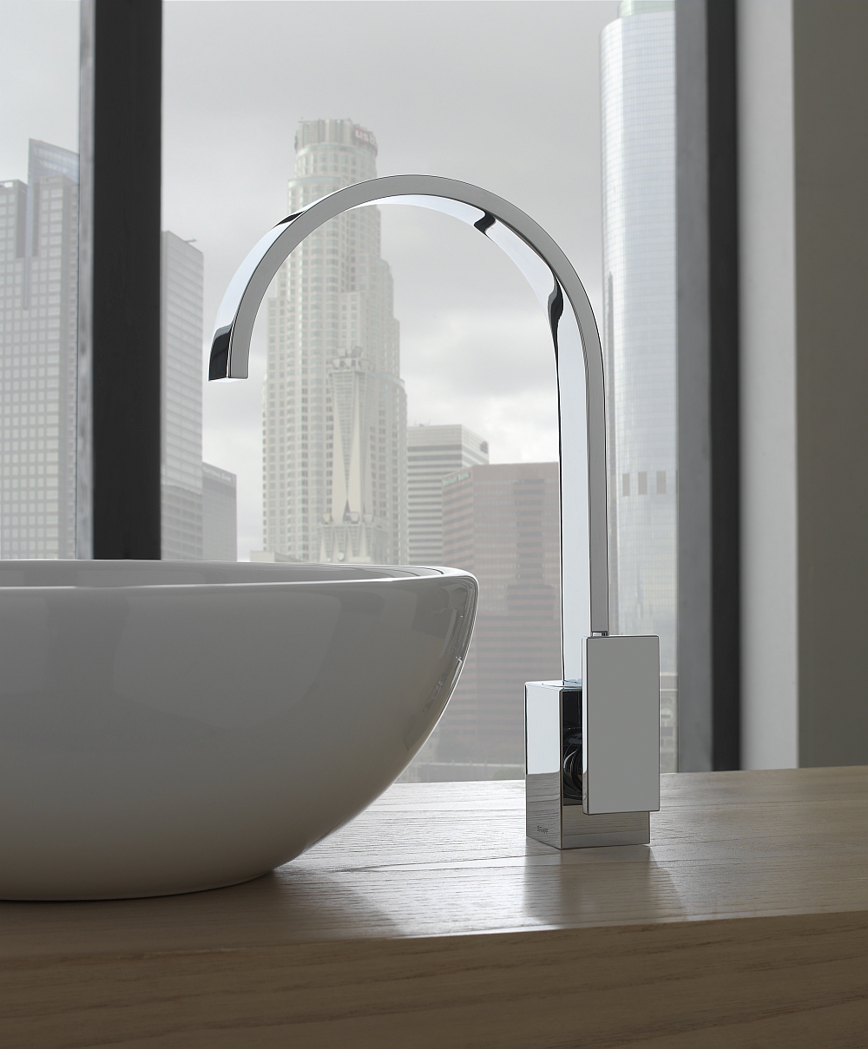

Deck-mounted washbasin mixer in PC (polished chrome)
Vessel lavatory mixer in PC (polished chrome)

