Press release
February 2018

Florence Luxury Suites Adorned with GRAFF’s Finezza Faucets
Sophisticated Collection used to elevate bathroom spaces

The stunning Florence Luxury Suites, an exclusive guest residence located behind the historic Santa Maria Novella in Florence, Italy has opened its doors to travelers with a taste for opulence. Incorporating elegant details throughout the entirety of the property, the residence affords guests the best in modern luxury and high design.
Located where GRAFF Europe is based and enriched with elements that pay homage to its Italian setting, the hotel’s bathroom suites are equipped with GRAFF’s Finezza Collection. The collection mirrors the artisan flavor of the Tuscan region, with finely sourced materials and technologically advanced components.
By combining high technology and attention to design, Finezza fulfills the pragmatic functions of everyday use and, at the same time, furnishes the bathrooms of the Florence Luxury Suites in a refined and contemporary way.
Designed internally by the G+Design Studio, Finezza is characterized by a set of architectural details that are combined with clean and essential lines. The body of the mixer offers an original shape, wider at the base and at the top part, thinner in the central section. The collection is an expression of a lifestyle that embraces designs from the past reinterpreted in a modern way.
The series is available both in the 3-hole and single-lever versions and presents a complete variety of deck-mounted and wall-mounted elements together with several installations for the shower. The faucets in polished chrome and polished nickel finishes are easily adaptable to a transitional environment, while the olive bronze and brushed nickel finishes represent a jewel for traditional bathrooms. Upon request, Finezza can also be ordered in gold and the new brushed gold finish.
Editor’s note: FINEZZA taps are produced in brass with a very low nickel and lead content and made in compliance with drinking water regulations, as required by the company policy, fully satisfying the most restrictive criteria required for the protection of health and the environment.

Florence Luxury Suites
Via Iacopo da Diacceto, 40, 50123 Firenze FI, Italy

IMAGES

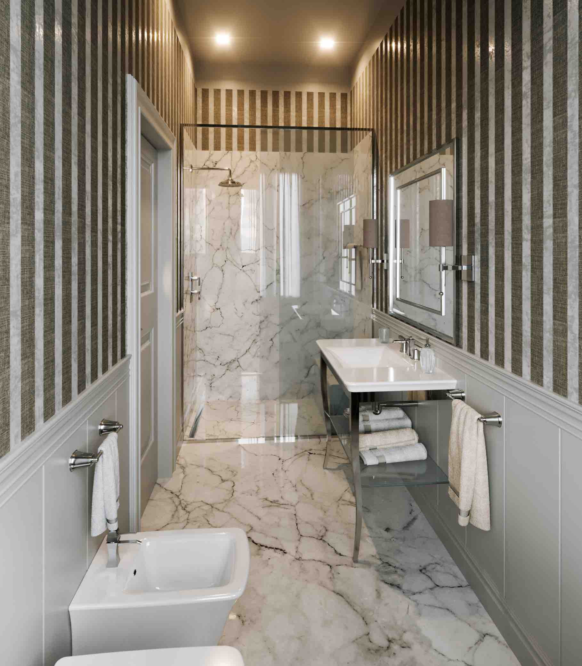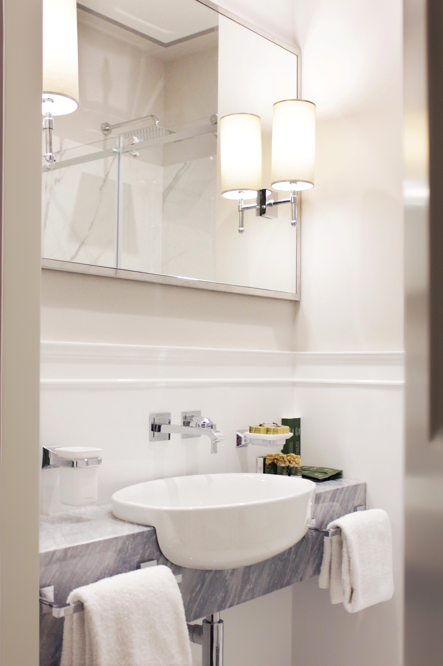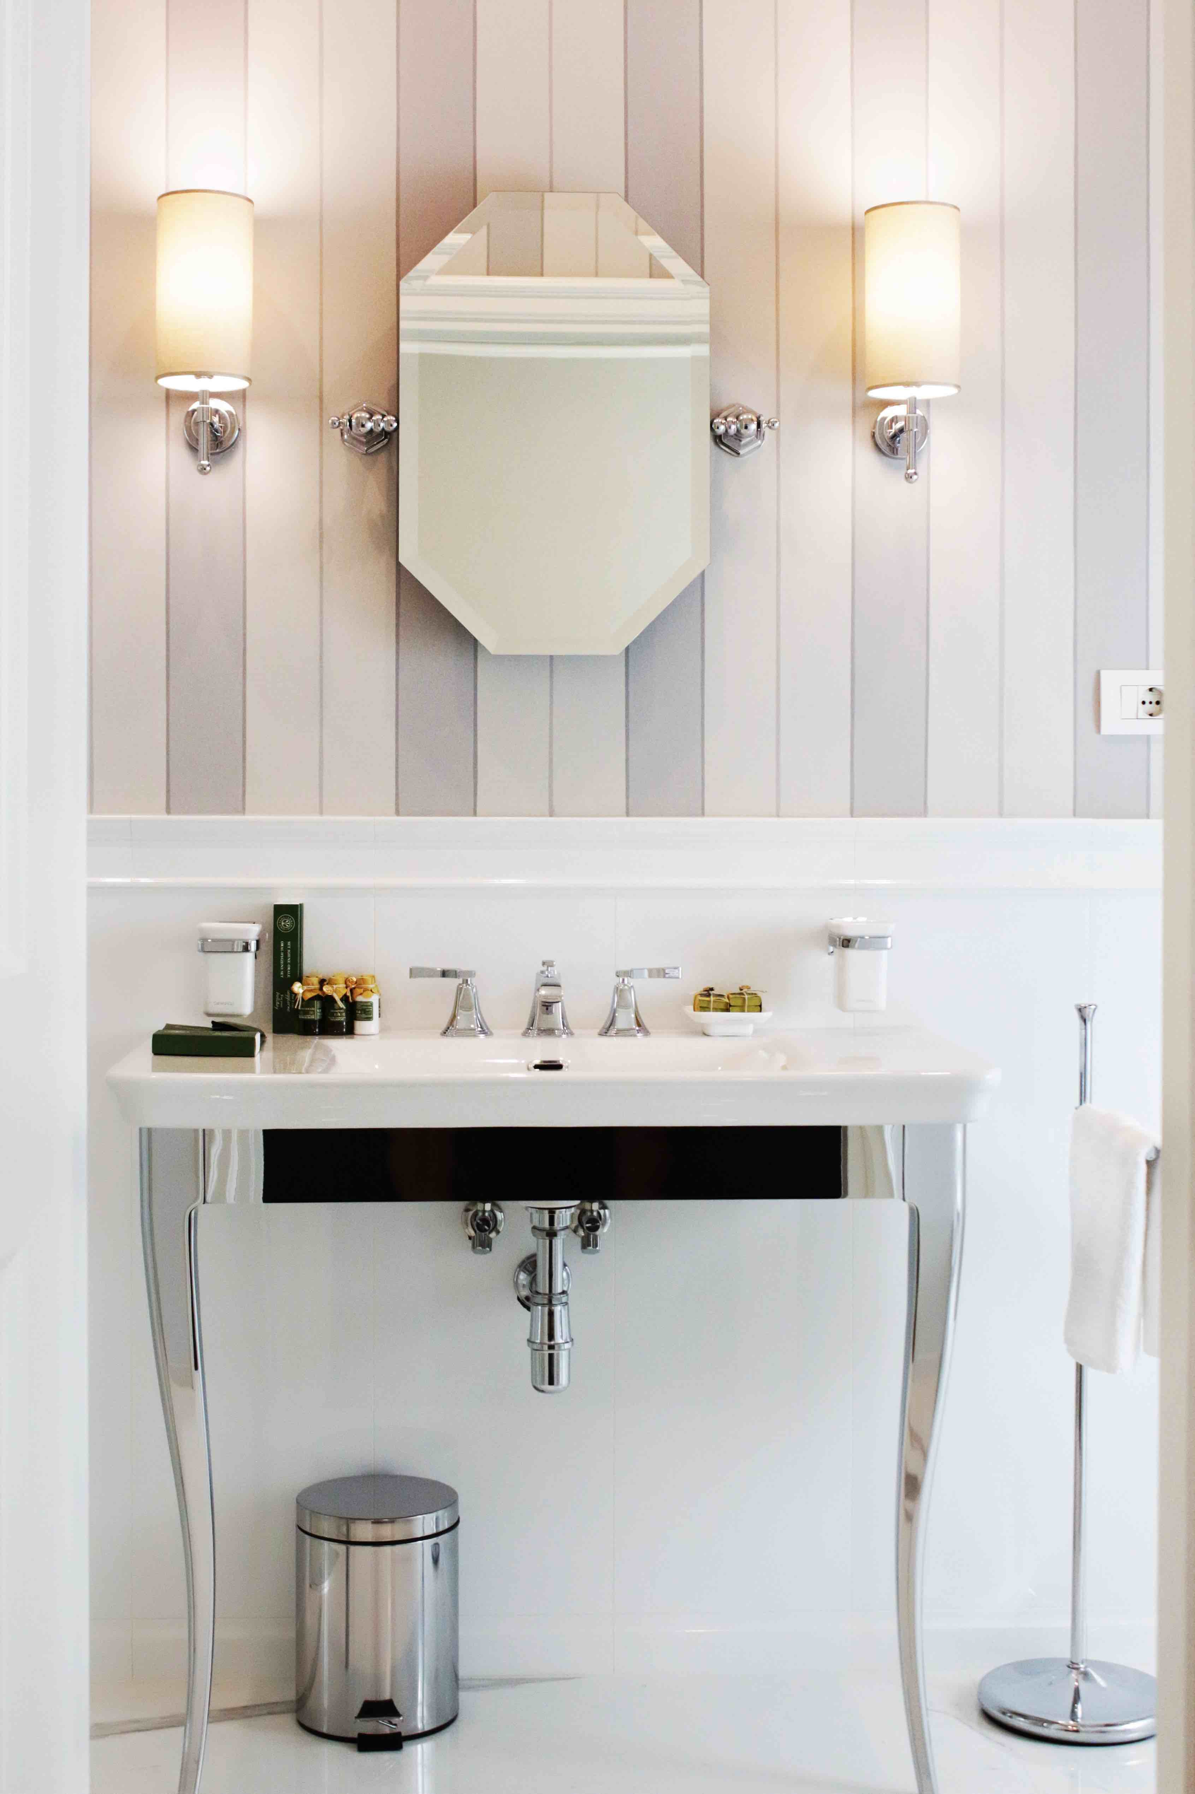

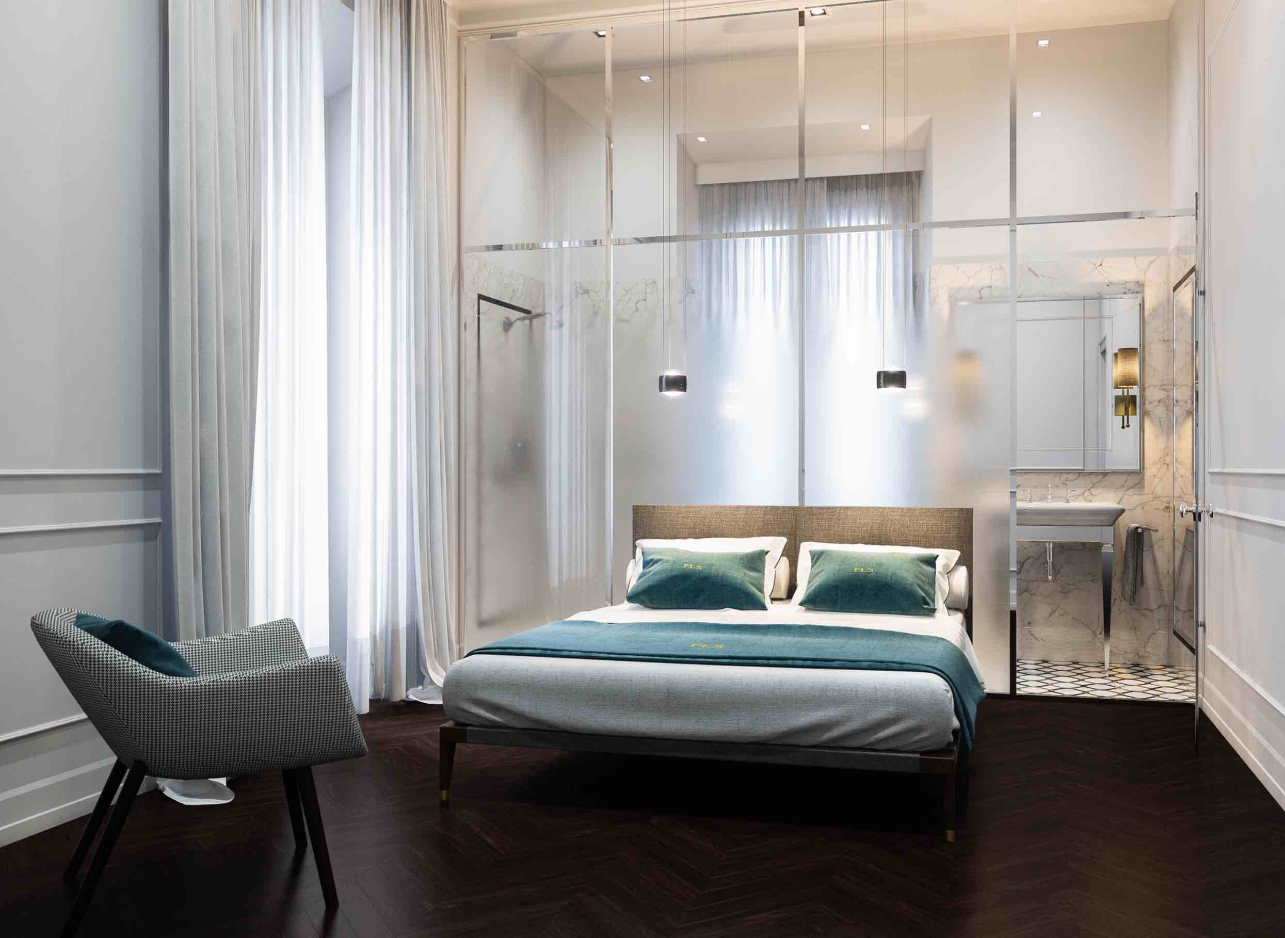
GRAFF EUROPE
Via Aretina 159, 50136 Florence - ITALY
Tel: +39 055 9332115,
fax: +39 055 9332116
email: info@graff-mixers.com
www.graff-designs.com

Press Office
tac comunic@zione milano|genova
tel +39 02 48517618 | 0185 351616
press@taconline.it | www.taconline.it

