Press Release
Milan Design Week
Salone del Mobile
April 21–26, 2026

Nodo Italia at Fuorisalone: a dialogue with Antonio Marras
During Fuorisalone, Nodo Italia is featured in the NonostanteMarras space, where designer Antonio Marras presents the immersive installation PicNic a Le Vasche di Ciu’ Peppì, a project that intertwines fashion, design, art, and the memory to Sardinia.
The installation unfolds as an evocative landscape inspired by the island’s beaches: intense light, salty wind, and the colors of Mediterranean scrub vegetation become chromatic and material references that run through furniture and surfaces. The green of juniper and wild olive trees, the ochre of earth, the red of stone, and the deep blue of the sea build the installation palette.
Within this setting, a seaside mood is reinterpreted in a contemporary key, where outdoor becomes a space of calm and conviviality. Antonio Marras + Nodo Italia furniture is expressed through indoor and outdoor collections including rattan armchairs, umbrellas, rugs, the Beach House daybed and pouf, the Via tile table, the Bistrot folding chair and the Pantheon pouf.
The compositional elements create small landscapes of relaxation: textile surfaces woven with Olyna® yarn, sand and écru tones, natural textures that interact with the context, creating continuity between furniture and environment.
The result is a light, Mediterranean atmosphere where objects seem to emerge naturally from the landscape, like temporary structures on the beach. The project proposes an experience of conviviality where design, material, and landscape engage in an harmonious dialogue.
A collaboration between fashion and design that has continued for three years and finds its most evocative expression at Milan Design Week 2026.
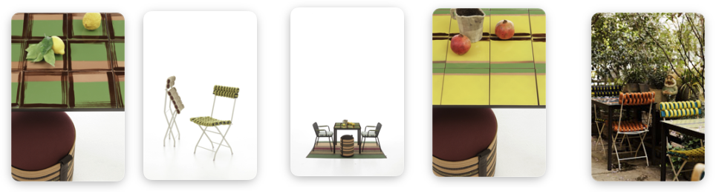
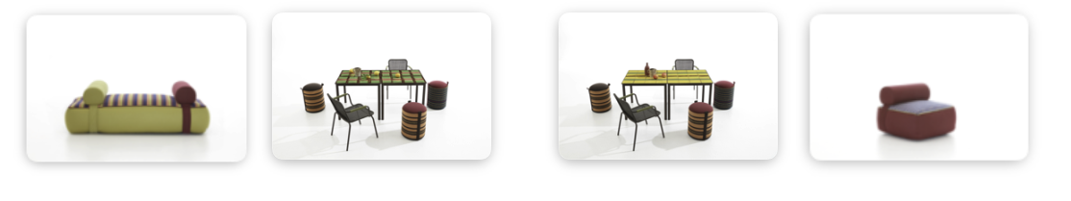
*These and other images are available in the press kit

The partnership with Jacuzzi
Within the NonostanteMarras space, the collaboration between Jacuzzi, Nodo Italia and Antonio Marras takes shape with Skylounge® upholstered in fabric, a new frontier for outdoor design.
The Skylounge® hot tub, designed by DNA | Kaluderovic & Condini for Jacuzzi®, is presented for the first time with panels covered in Antonio Marras + Nodo Italia technical fabric, produced by Leolori. Pure innovation: a hot tub upholstered in high-performance technical fabric, expanding design possibilities between furniture, architecture, and wellness.
The Olyna® fabric panels guarantee resistance to chlorine, sunscreen stains, abrasion, UV rays, saltwater, and chemical agents, while maintaining a soft and pleasant tactile surface. The materials are OEKO-TEX Class 1 certified, washable, and easy to sanitize, making them particularly suitable for spa and outdoor environments.
Alongside the Blue Navy and Taupe versions, a special Antonio Marras + Nodo Italia edition is presented at Fuorisalone, expressing a shared research on the language of surfaces and the narrative value of materials. In Alcantar Small Stripes, Alcantar Big Stripes, and Tartan fabrics.
From a technological perspective, Skylounge® maintains Jacuzzi®’s distinctive features: ClearRAY® Pro3tect™ filtration and disinfection system, automatic heating, PowerPro® jets for differentiated massage, and underwater LED lighting. Its dual-depth internal configuration and compact dimensions also allow installation on terraces.
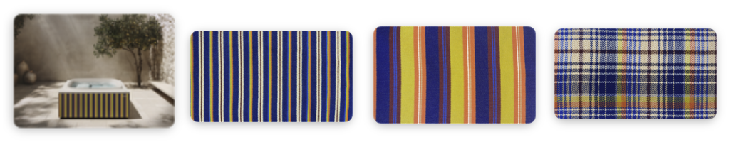
* All images are available, properly labeled, within the press kit

Quote — Matteo Seroldi, CEO of Nodo Italia
“At Milan Design Week we have initiated collaborations with important Italian design brands that have chosen our collections for the craftsmanship value of our production, the quality of our textile world, and our aesthetic research,” says Matteo Seroldi, CEO of Nodo Italia.
“Our work comes from the evolution of ancient knowledge: imagining how yarn, a pure raw material, can be interpreted to give life to design objects and art. The collaboration between Jacuzzi, Antonio Marras, and Evelina Kroon represents the harmonious union of worlds seen from different perspectives.

The narrative of Nodo Italia material comes to life during Milan Design Week 2026 through several projects and installations at the fair and across the Fuorisalone circuit. Here is the summary:

Salone del Mobile
@ Hall 18 | Stand C04

Fuorisalone
@ NonostanteMarras — Antonio Marras + Jacuzzi
Via Cola di Rienzo 8
@ Artemest
Palazzo Donizetti
Via Gaetano Donizetti 48
@ DGA Showroom
Corso Monforte 23

Press Office + Digital PR:
TAConline
www.taconline.it

Press requests:
press@taconline.it

NODO ITALIA
nodoitalia.com
info@nodoitalia.com

