SALONE INTERNAZIONALE DEL MOBILE
21-16 aprile 2026
Fiera di Rho, Hall 14 Stand E 44

PRESS WELCOME ON SITE
21-22-23 aprile
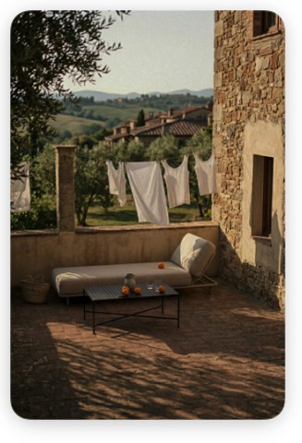
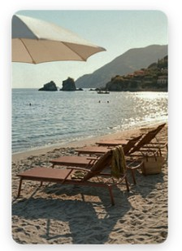
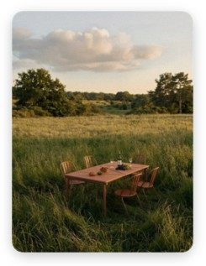
ore 10:00-17:00

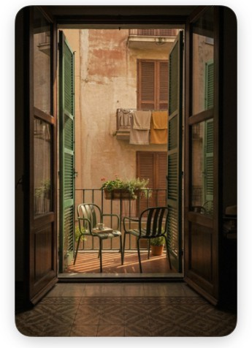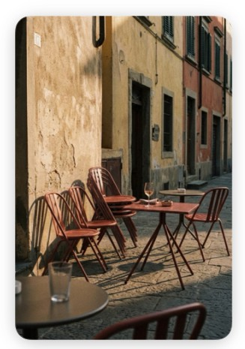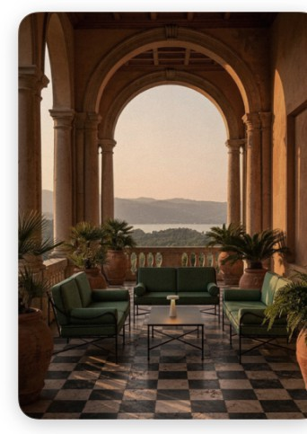

VERMOBIL PRESENTS “TRUE ITALIAN OUTDOOR” AT THE SALONE DEL MOBILE
A new exhibition concept and an evolution of the brand identity for the Italian outdoor furniture brand
THE SQUARE, METAL, OUTDOOR LIVING
There is a moment in Italy when the light softens and the squares begin to fill up. Chairs are brought out of the houses, tables are pushed together, voices mingle.
It is not an event, but a daily ritual: being together, outdoors.
It is from this image — more cultural than design-oriented — that Vermobil’s new direction takes shape.
At the Salone del Mobile Milano 2026, the company presents True Italian Outdoor: not a stand, but a narrative environment that takes the form of an Italian village square. A contemporary square where design ceases to be an isolated object and returns to its original dimension: relationship.
The Village is not a stage set, but a statement of intent.
Vermobil chooses not to build a closed system, but rather an open, porous, traversable community. A collection of presences — designers, talents, visions — that come together, influence one another and transform over time.
A model that transcends the rigidity of the ecosystem to embrace the complexity of reality: made up of fleeting encounters, spontaneous collaborations and constant exchanges.
Here, the brand does not impose itself: it places itself at the centre to make room for others.

AN UNFILTERED ITALY
There is an Italy that needs no introduction, for it is instantly recognisable. It is the Italy of squares and courtyards, of wrought iron and weathered surfaces, of simplicity that effortlessly transforms into elegance. An Italy that belongs not to nostalgia, but to the present.

The Village’s imagery draws on the Amalfi Coast of the 1960s — a time suspended between cinema and reality — where the iconic presence of the great stars of Italian cinema of the era (Virna Lisi, Sofia Loren, Gina Lollobrigida, Anna Magnani, Claudia Cardinale and Monica Vitti) becomes a cultural rather than an aesthetic reference.

SPACE AS AN EXPERIENCE
The stand is constructed in fragments, like a landscape to be traversed.
Walls marked by free, never-repeated brushstrokes of colour. Colours that seek not uniformity, but vibrancy. Surfaces that convey a gesture, rather than a design. A desk transforms into a counter. A counter becomes a meeting place.
Colourful market crates become design objects. Lemonade is served, catalogues are leafed through, conversations take place.
It is in this suspension between function and informality that the project finds its balance: not representing the outdoors, but staging it as it naturally unfolds.

THE CHANGE OF IDENTITY
If the Village is the form, the rebranding is the structure.
Vermobil is undergoing a necessary transition: from a recognised manufacturer to a desirable brand. Not by changing what it is, but by making it visible.
The new logo — sharper, more legible, more deliberate — seeks not decoration, but presence. Classic Italian typography becomes a visual identity. The language is simplified. A statement is born: Vermobil. True Italian Outdoor.
A phrase that does not explain, but asserts. That does not translate, but positions. With the support of the Parisian agency Cake Design.

METAL AS A LANGUAGE
In a rapidly changing market, Vermobil chooses continuity.
Metal — steel, stainless steel, aluminium — is not just a material, but expertise. A know-how built up over time: welding, bending, protecting.
There is no desire to chase every trend. There is an intention to build objects that last. Manufacturing in Italy, in this sense, is not a stated value: it is an operational choice. More complex, but necessary to maintain a balance between quality, price and identity.

THE COLLECTIONS: TIMELESS FORMS
The new collections blend seamlessly into this landscape.
The designs by Patrick Norguet, Florent Coirier, Marcello Ziliani and Nicola Bonriposi do not seek to take centre stage, but rather to achieve coherence.
Measured forms, controlled proportions, transparent materials.
Seating, tables and lounge systems that do not create an image, but form part of a wider scene: that of outdoor living.

A MATTER OF DESIRE
The most important shift is not formal, but cultural.
Vermobil no longer wishes to be merely a rational choice, but to become a desired choice. To generate demand before responding to it. To enter the imagination, not just the catalogues.
To achieve this, the brand focuses on imagery, photography and storytelling. It crafts a vision.

DESIGN AND NEW COLLECTIONS
The new collections presented at the Salone are part of this evolutionary journey, combining design rigour with references to the Mediterranean imagination.

Virna — design by Patrick Norguet
Inspired by the grand terraces of the Amalfi Coast, Virna is a lounge system characterised by balanced proportions and a stainless steel frame, complemented by elegant cushions crafted with sartorial attention to detail.

Pupa — design by Patrick Norguet
Envisioning the Italian bars and cafés of the future, Patrick Norguet designed Pupa. A contract seating solution with a galvanised steel frame and a minimalist design language, conceived for contemporary hospitality settings.

Andre — design by Florent Coirier
A seating solution combining aluminium and polypropylene, designed to offer lightness, durability and versatility in the contract sector.

Orme — design by Nicola Bonriposi
A collection of tables with a galvanised steel frame and tops in HPL or ceramic, available in various sizes.

Volée — design by Marcello Ziliani
The lounger and table complete the collection with a combination of aluminium and steel, featuring an original interweaving of fabric strips, whilst maintaining formal coherence and visual lightness.

VERMOBIL
Vermobil is a company specialising in the production of outdoor and contract furniture in steel, stainless steel and aluminium.
With over 35 years of experience, it combines:
• 100% Italian manufacturing
• expertise in metalworking
• flexibility and customisation
• an international distribution network
Its collections furnish residential and hospitality spaces worldwide, with an approach that combines quality, durability and design innovation.

Press Office and Digital PR: TAConline
press@taconline.it www.taconline.it
Contacts:
Paola Staiano staiano@taconline.it
Giulia Solari solari@taconline.it

Vermobil Style Srl
Via Antonio da Migliano, 1 06055 Marsciano (PG) www.vermobil.it vermobil@vermobil.it
+39.075.8742662

