Press Release
Milan Design Week
Salone del Mobile
April 21–26, 2026

BEYOND OUTDOOR
From yarn to living space: a project that unites material, design, and landscapes

On the occasion of Milan Design Week 2026, Nodo Italia returns to Salone del Mobile with Beyond Outdoor, a design concept born from an ongoing reflection on how outdoor spaces are experienced.
More than a simple presentation, Beyond Outdoor is a way of thinking about design. The exhibition space is conceived as a light and essential environment, built through a subtractive approach in which every element has a precise role. The route unfolds as a fluid sequence of spaces that suggest continuity between indoor and outdoor environments, overcoming the traditional boundaries of outdoor furniture.
Materials, colors, and weaves are designed to naturally adapt to different contexts while maintaining a coherent visual language. Sand, water, fire, and other natural elements enter the narrative not as scenography, but as metaphors for resistance, flexibility, and freedom.
The atmosphere remains calm, minimal, and welcoming.
This vision is reflected in the versatility of Nodo Italia products, designed for cross-use between indoor and outdoor environments. The collections are developed to respond to both residential and contract contexts, also supported by technical certifications such as passing the Methenamine Pill Test, confirming their flame-retardant properties and suitability for indoor and outdoor use.
At the core of the project is Olyna®, the patented yarn developed by Nodo Italia: a polyolefin fiber treated with anti-oxidizing additives and UV stabilizers to ensure high performance in outdoor use and in environments exposed to chlorine, salt, bacteria, and stains. It is 100% recyclable and available in endless colors.
The collections* Eva, Zip, Brique, Sospiro, and Rugs represent the highest expression of this technical and stylistic research.

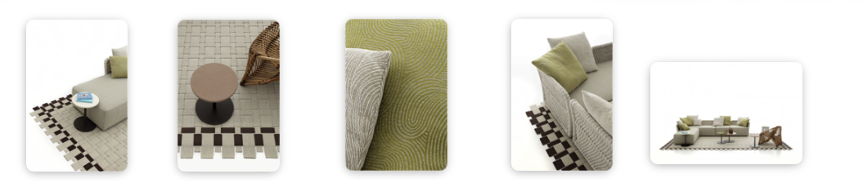

Brique in Siena fabrics and rug Dama
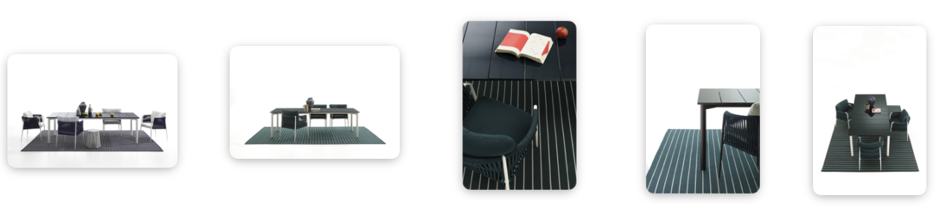
Sospiro

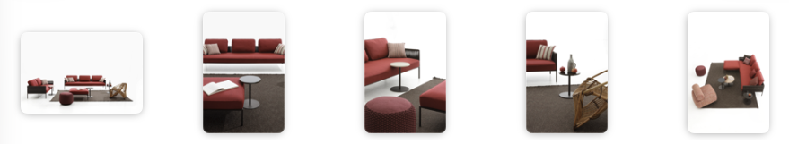

Zip in Sakura

*These and other images are available in the press kit

Focus Rugs: Evelina Kroon
Nodo Italia rugs are born from research into materials, textures, and construction techniques capable of naturally interpreting both indoor and outdoor spaces. Entirely handmade in Italy with woven Olyna® belts, they combine formal elegance with resistance to atmospheric agents, becoming true design elements capable of defining the identity of a space. The color palette reflects Nodo Italia’s collections, creating visual continuity between surfaces, furniture, and textiles.
The collaboration with Evelina Kroon, a Stockholm-based Swedish artist and designer known for her unmistakable visual language made of geometric patterns and a sophisticated use of color, represents the desire to share and expand the Nodo Italia universe with visionary artists with a coherent language.
Kroon’s compositions meet the chromatic intensity of Olyna®, transforming the rug into a living presence that changes with light, space, and time. Lines expand and contract, colors meet and soften, generating a visual rhythm that becomes almost physical: a rhythm of lines and colors that defines the environment.
Each project is born from a dialogue between vision and execution, where proportion, repetition, and density are calibrated to preserve the energy of Evelina Kroon’s visual language while still leaving space for the material.
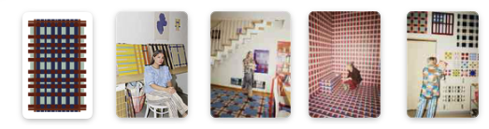

Rug Collections
The rug collections in the catalogue are always developed from cultural and material inspirations.
- Bali explores an essential and meditative aesthetic.
- Bellagio reinterprets the elegance of Lake Como villas through contemporary palettes.
- Borneo draws inspiration from rainforest nature, translating the strength of roots and vegetation into textured weaves.
- Dama recalls the ancient basket weave technique of clothing accessories, amplifying interlacing and crossings.
- Cloud proposes soft, enveloping forms designed for relaxed outdoor environments.
- Fabric (Panama and Tartan) reinterprets the tradition of Nepalese rugs through contemporary technologies.
- Laguna, an evolution of Bellagio, introduces fluid and organic forms that interact with nature.
- Among the more experimental collections, Montecarlo references the aesthetic of 1980s Italian fashion, using braids produced with a technique typical of men’s belts.
- Portofino translates Mediterranean architectural harmony into essential and elegant lines.
- Vulcano develops a round spiral design, hand-crafted and inspired by 1970s psychedelic patterns. Vulcano stands out for a continuous spiral made from a single rope, starting from the center and developing endlessly. A bold and hypnotic design that transforms rhythm and movement into a strong visual sign.

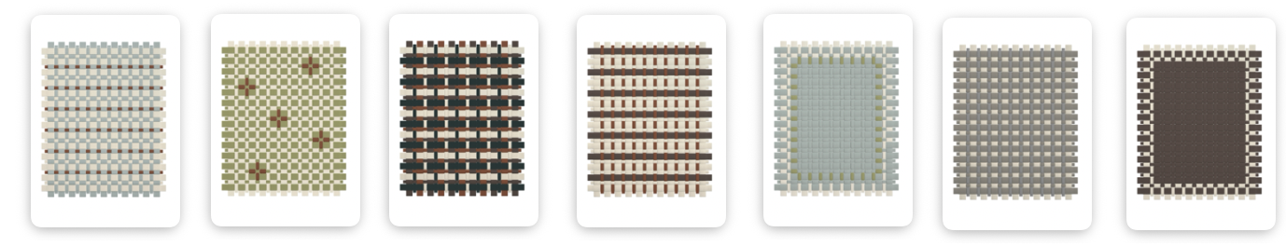

Rug Dama

*These images are of Dama rugs. Further images of the rugs are available in the press kit

Nodo Italia at Fuorisalone: a dialogue with Antonio Marras
During Fuorisalone, Nodo Italia is featured in the NonostanteMarras space, where designer Antonio Marras presents the immersive installation PicNic a Le Vasche di Ciu’ Peppì, a project that intertwines fashion, design, art, and the memory to Sardinia.
The installation unfolds as an evocative landscape inspired by the island’s beaches: intense light, salty wind, and the colors of Mediterranean scrub vegetation become chromatic and material references that run through furniture and surfaces. The green of juniper and wild olive trees, the ochre of earth, the red of stone, and the deep blue of the sea build the installation palette.
Within this setting, a seaside mood is reinterpreted in a contemporary key, where outdoor becomes a space of calm and conviviality. Antonio Marras + Nodo Italia furniture is expressed through indoor and outdoor collections including rattan armchairs, umbrellas, rugs, the Beach House daybed and pouf, the Via tile table, the Bistrot folding chair and the Pantheon pouf.
The compositional elements create small landscapes of relaxation: textile surfaces woven with Olyna® yarn, sand and écru tones, natural textures that interact with the context, creating continuity between furniture and environment.
The result is a light, Mediterranean atmosphere where objects seem to emerge naturally from the landscape, like temporary structures on the beach. The project proposes an experience of conviviality where design, material, and landscape engage in an harmonious dialogue.
A collaboration between fashion and design that has continued for three years and finds its most evocative expression at Milan Design Week 2026.
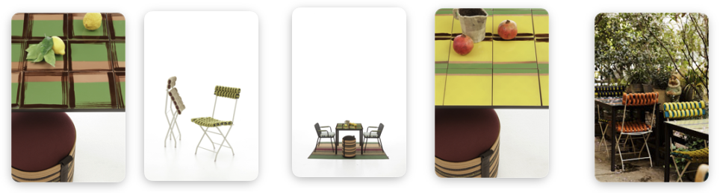
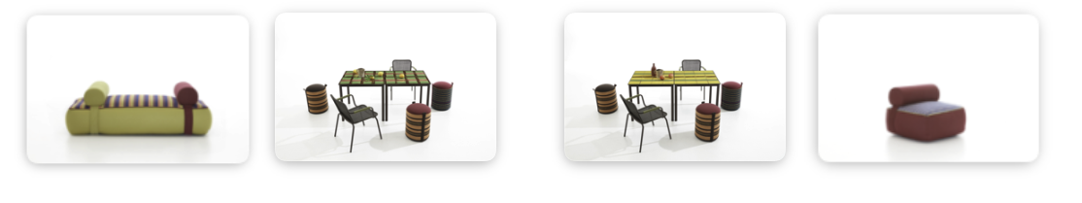
*These and other images are available in the press kit

The partnership with Jacuzzi
Within the NonostanteMarras space, the collaboration between Jacuzzi, Nodo Italia and Antonio Marras takes shape with Skylounge® upholstered in fabric, a new frontier for outdoor design.
The Skylounge® hot tub, designed by DNA | Kaluderovic & Condini for Jacuzzi®, is presented for the first time with panels covered in Antonio Marras + Nodo Italia technical fabric, produced by Leolori. Pure innovation: a hot tub upholstered in high-performance technical fabric, expanding design possibilities between furniture, architecture, and wellness.
The Olyna® fabric panels guarantee resistance to chlorine, sunscreen stains, abrasion, UV rays, saltwater, and chemical agents, while maintaining a soft and pleasant tactile surface. The materials are OEKO-TEX Class 1 certified, washable, and easy to sanitize, making them particularly suitable for spa and outdoor environments.
Alongside the Blue Navy and Taupe versions, a special Antonio Marras + Nodo Italia edition is presented at Fuorisalone, expressing a shared research on the language of surfaces and the narrative value of materials. In Alcantar Small Stripes, Alcantar Big Stripes, and Tartan fabrics.
From a technological perspective, Skylounge® maintains Jacuzzi®’s distinctive features: ClearRAY® Pro3tect™ filtration and disinfection system, automatic heating, PowerPro® jets for differentiated massage, and underwater LED lighting. Its dual-depth internal configuration and compact dimensions also allow installation on terraces.
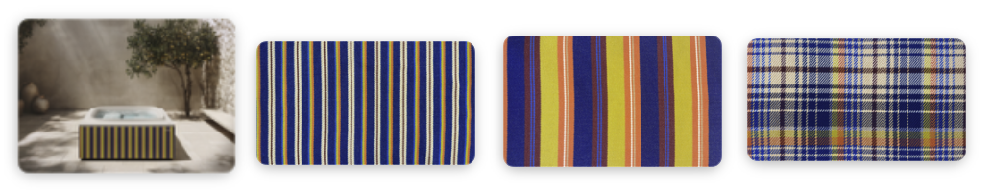
* All images are available, properly labeled, within the press kit

Quote — Matteo Seroldi, CEO of Nodo Italia
“At Milan Design Week we have initiated collaborations with important Italian design brands that have chosen our collections for the craftsmanship value of our production, the quality of our textile world, and our aesthetic research,” says Matteo Seroldi, CEO of Nodo Italia.
“Our work comes from the evolution of ancient knowledge: imagining how yarn, a pure raw material, can be interpreted to give life to design objects and art. The collaboration between Jacuzzi, Antonio Marras, and Evelina Kroon represents the harmonious union of worlds seen from different perspectives.

The narrative of Nodo Italia material comes to life during Milan Design Week 2026 through several projects and installations at the fair and across the Fuorisalone circuit. Here is the summary:

Salone del Mobile
@ Hall 18 | Stand C04

Fuorisalone
@ NonostanteMarras — Antonio Marras + Jacuzzi
Via Cola di Rienzo 8
@ Artemest
Palazzo Donizetti
Via Gaetano Donizetti 48
@ DGA Showroom
Corso Monforte 23

Press Office + Digital PR:
TAConline
www.taconline.it

Press requests:
press@taconline.it

NODO ITALIA
nodoitalia.com
info@nodoitalia.com

