SALONE DEL MOBILE | 2018 MILAN DESIGN WEEK
PRESS KIT

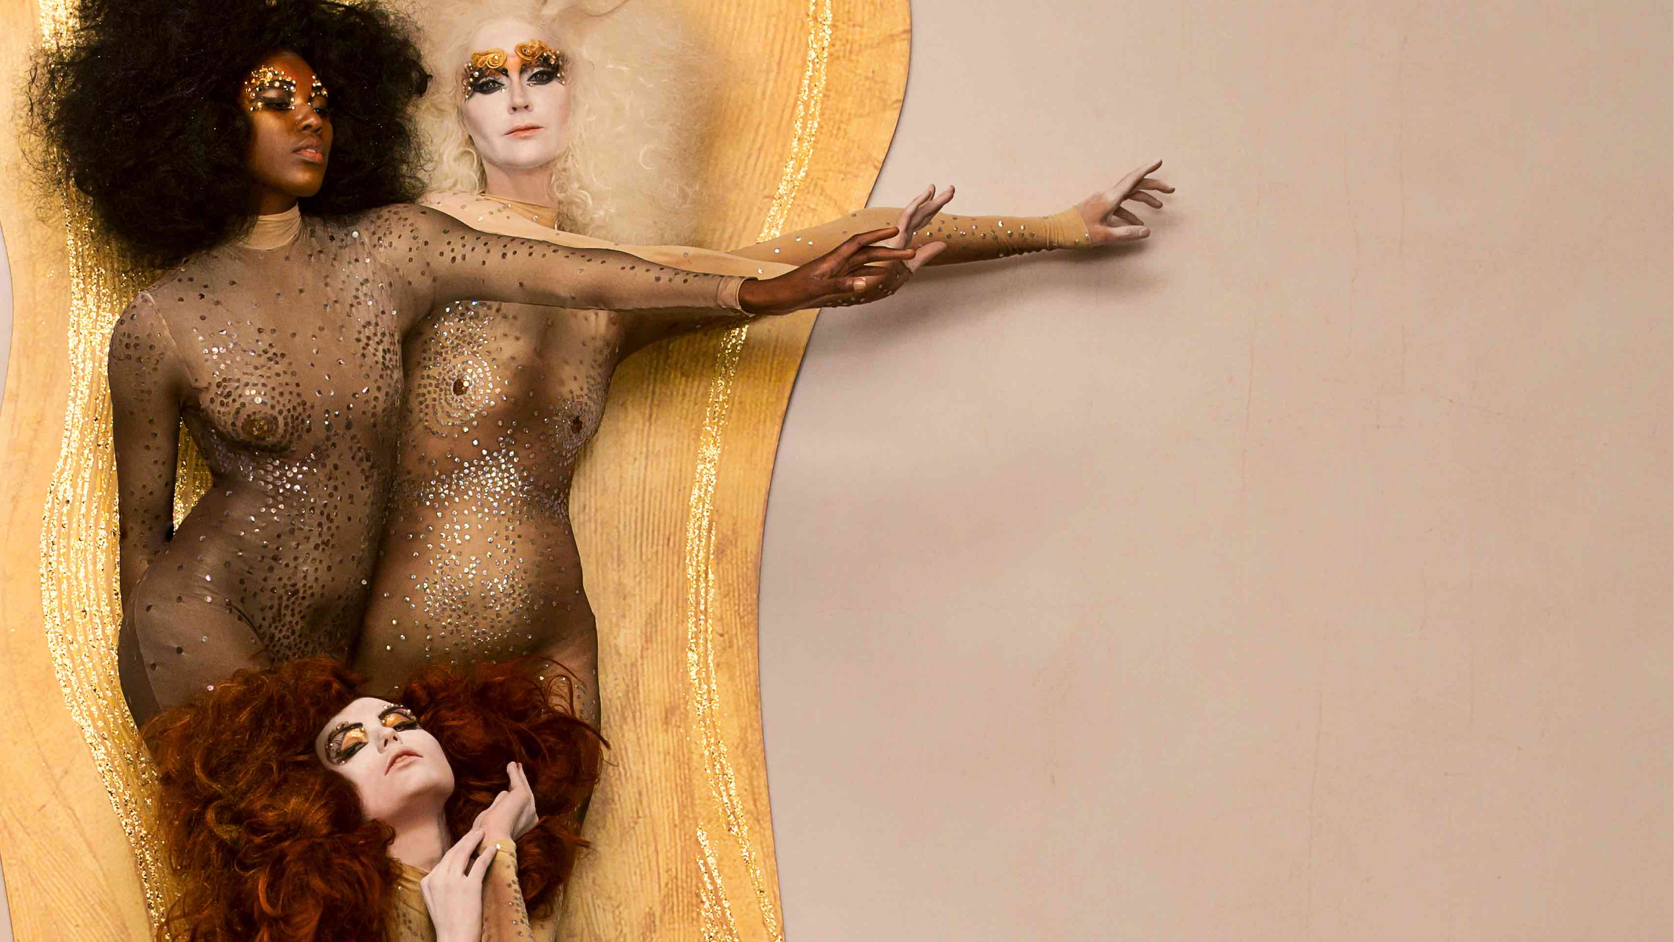

1. ART OF BATH
• INGE PRADER’s mASTERPIECES "DIRECTED" BY DCUBE.SWISS

2. DESIDERI AND GRAFF'S TOTAL LOOK
• A Close up of the CHARIS BASIN AND musa COLLECTION (BATH AND SINK)

3. incanto
• A COLLECTION OF CONTEMPORARY FAUCETS
• iNCANTO IN ONyx, OR'OSA AND GUNMETAL FINISHES are AMONG THE NEW textures

------------------------------------------------------------------------------------
AT SALONE
Hall. 22 Booth E28
17 - 22 APRIL 2018 | 9.30 - 18.30
17 -18 APRIL: COCKTAIL 4 PRESS

1. ART OF BATH
• THE INGE PRADER WORKS “DIRECTED” BY DCUBE.SWISS

From 17 to 22 of April, during the Milan Design Week, GRAFF will introduce the new 2018 collections for a contemporary and luxury style bathroom at the International Bathroom Exhibition (Hall 22, booth E28).

This year, the American brand, globally recognized for its excellence in bathroom design, will present several product collections created in the name of innovation. Washbasins, bathtubs, mixers and bathroom furniture draw upon recognizable geometries, naturally recalling the concept of timeless beauty.

Transposed inside the world of art through the works of the Viennese photographer Inge Prader, the new collections of faucets and accessories represent a modern expression and connect to GRAFF’s design theme, the ART OF BATH. The theme, or emotional journey, has been successfully executed for several years by the American company, merging classical artworks reinterpreted with modern bathroom designs for a visually enticing experience.

Inge Prader, a fascinating interpreter of some of Klimt's masterpieces such as Beethoven's Frieze (1902) and Danae (1907), recalls dreamy and delicate figures that intertwine in soft hugs and kisses, creating sensual and iconic images.

The space, designed by Dcube.swiss (Geneva), welcomes a series of harmonic and geometric projects: shower systems, faucets, bathtubs, washbasins and accessories, conversing with Inge Prader's works to create splendid iconographic plots lines.
Each element acts as the protagonist of the mise en scène, corresponding to a precise aesthetic philosophy: the search for timeless beauty.
The stand represents the perfect setting in which to present the company's innovations, especially the six new finishes - OR'osa PVD®, Onyx, Gunmetal, Gunmetal Distressed, Unfinished Brass, Unfinished Brushed Brass - which incorporate a palette of precious hues.

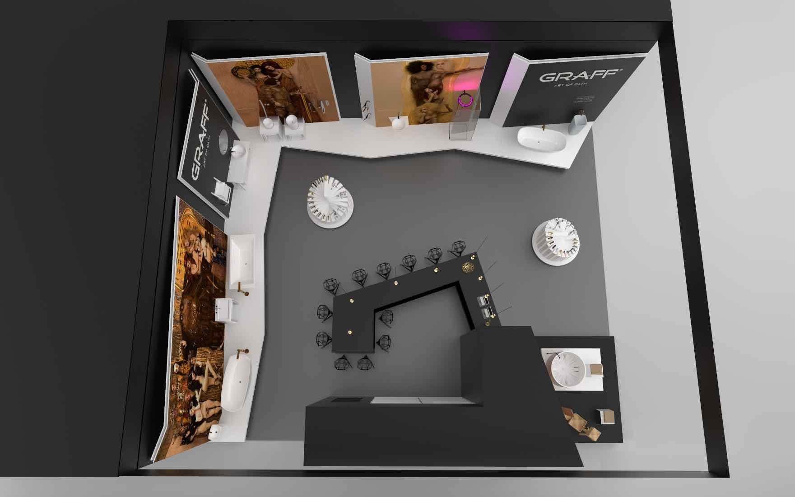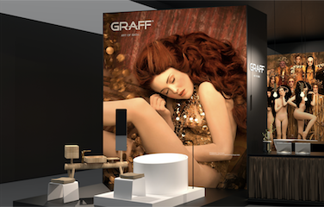

- DESIDERI, GRAFF’s TOTAL LOOK

DESIDERI includes two furniture collections, Dressage and Expo, and several washbasin and bathtub collections in SLEEK-STONE®, all designed to complete the wide range of GRAFF designs.

SLEEK-STONE® is a material created by GRAFF to give shape to its new bathtubs and washbasins. It is a composite material that combines 75% of dolomite minerals with a unique resin, creating a durable and natural-looking compound.
SLEEK-STONE® is soft to the touch, with a unique and luxurious smoothness that offers an exclusive and elegant experience in the bathroom.
Its anti-stain and UV-resistant properties make its surfaces easy to clean, with minimal maintenance.
The company employed cutting-edge technologies and artisanal processes for the creation of these sophisticated products, designed to have a high level of resistance at the molecular level.
The collections in the catalog offer solutions for all tastes: in a modern or transitional style, with countertop, floor-mounted or drop-in installation options. The freestanding bathtubs can be installed anywhere in the bathroom and come equipped with an integrated overflow system.

CHARIS, the elegant basin outfitted in SLEEK-STONE®, was born to furnish sophisticated bathrooms. The squared and perfectly clean lines make it a unique piece of furniture. Coming complete with a decorative drain cover furthers this concept, allowing the water to flow easily to the base of the basin without viewing the exposed drain.
Designed by the G+Design Studio, CHARIS becomes a functional, practical and beautiful piece of furniture to be seen. CHARIS is available in a gloss white or matte white finish.

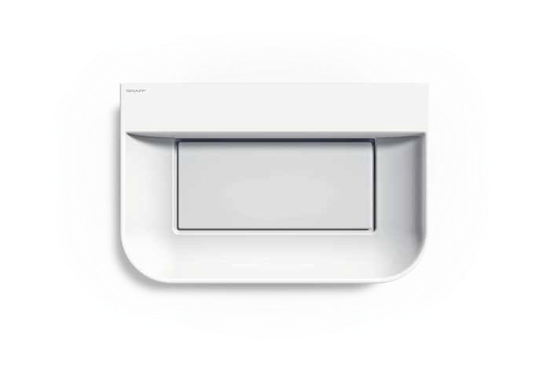

CHARIS basin INCANTO faucet
CHARIS washbasin

MUSA, the artistic and functional contemporary SLEEK-STONE® bathtub, reflects a modern taste that enriches the dialogue with architects, stylists and designers working on interiors.
Designed by the G+Design Studio, MUSA expresses a modern and refined taste. Soft lines, reminiscent of natural shapes, characterize both the bathtub and the coordinated washbasin.
The bathtub features an integrated overflow system and is the ideal solution to furnish any bathroom space.
The bathtub and basin can be combined with all GRAFF faucet models, especially the Phase and Sade collections. The MUSA collection is available in a gloss white or matte white finish.

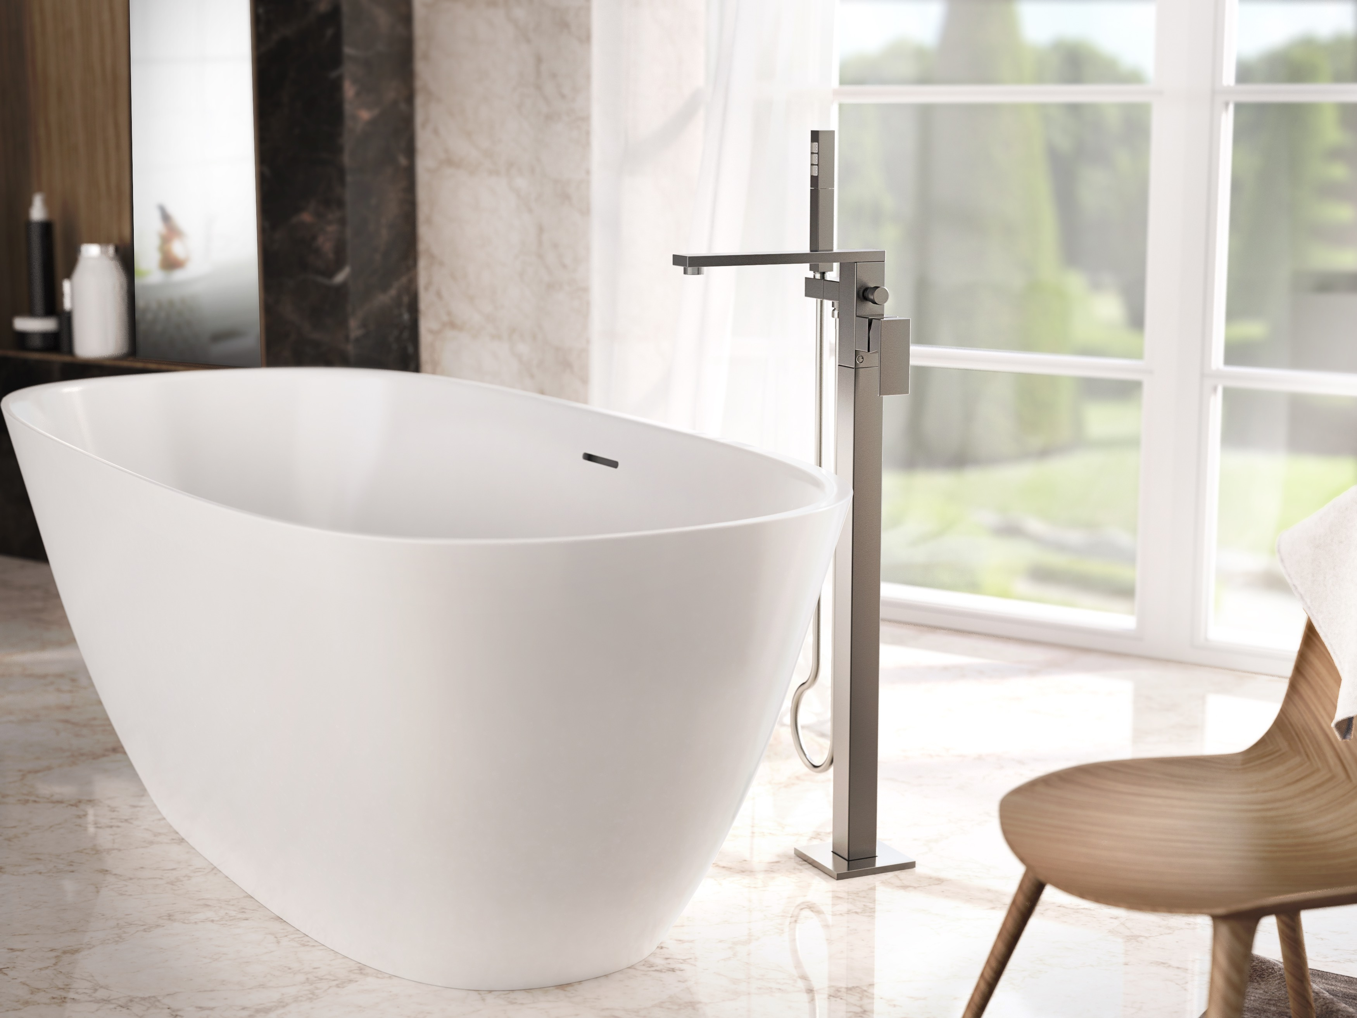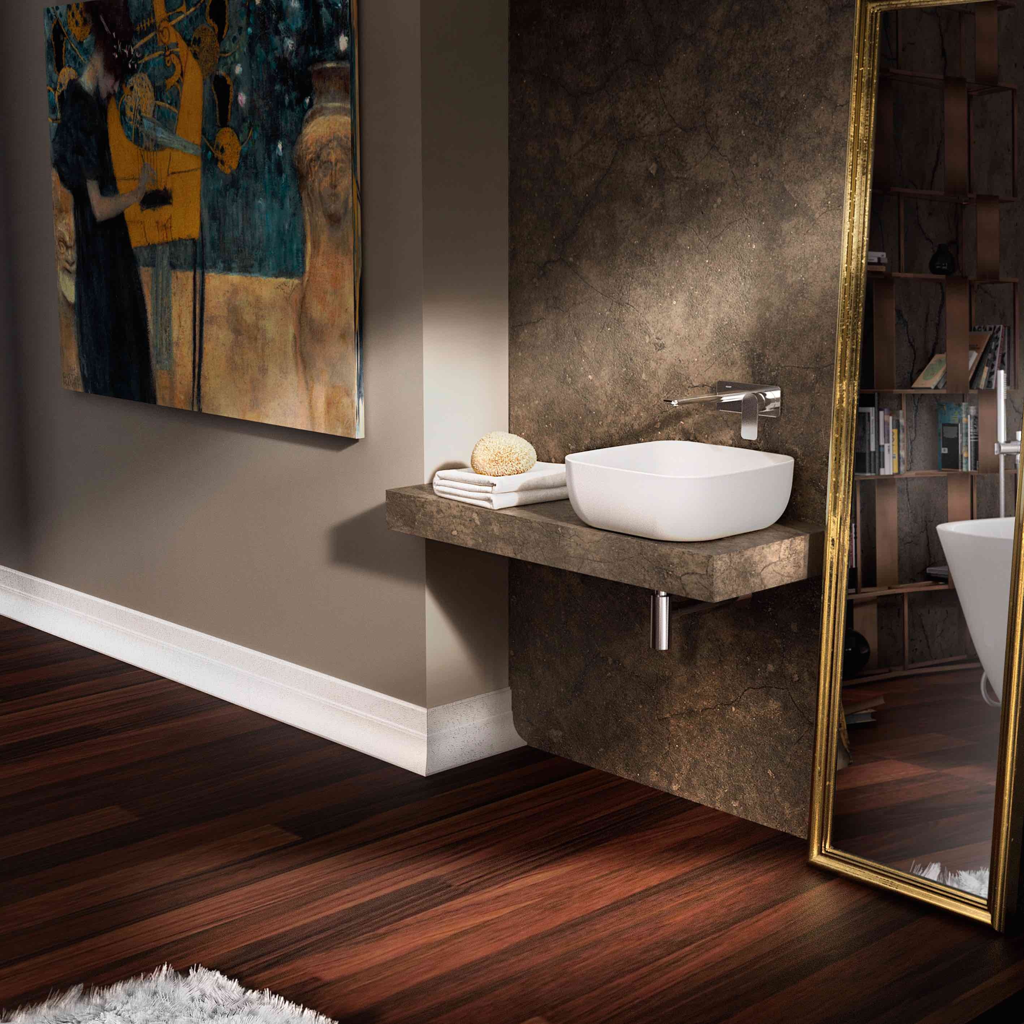
MUSA bathtub MUSA basin

- INCANTO
- A collection of contemporary faucets
- INCANTO in the new finishes
- ONyx, OR’osa PVD® and GUNMETAL, among the new textures

INCANTO was created under the inspiration of contemporary design and is GRAFF’s new glamorous collection including deck-mounted, wall-mounted and free-standing elements.
GRAFF, with its vast industrial background, has always been at the forefront of innovation and its guiding principles are clearly demonstrated with this new collection.

Incanto is characterized by modern square lines and consists of several faucet variations for washbasins, bathtubs and the shower area. These options include both a single lever and three-hole option, as well as a full range of matching accessories.

Incanto will be available in all GRAFF finishes, including the six new astonishing finishes: OR'osa PVD®, Onyx, Gunmetal, Gunmetal Distressed, Unfinished Brass and Unfinished Brushed Brass.

Onyx recalls the complex color of black onyx, while the Unfinished Brass and Unfinished Brushed Brass are two living finishes intended to change color over time and assume the natural color of aged brass.

With a solid and appealing texture, Gunmetal is a finish with a very warm, soft to the touch feel. Fading out to the edges, the color contains elements of dark grey mixed with warm hints of brown.

The Gunmetal Distressed finish, with its “rugged” surface and industrial feel, carries a very natural look that emulates a stone surface. Both finishes are obtained through a galvanic plating process, completed with an industrial waxing procedure.

Among the aspects to be reported, which are common to all the collections, is the attention to raw materials. GRAFF is among the first companies in the world to have adopted the strictest international standards to eliminate any residual lead inside the brass used to develop its faucets.

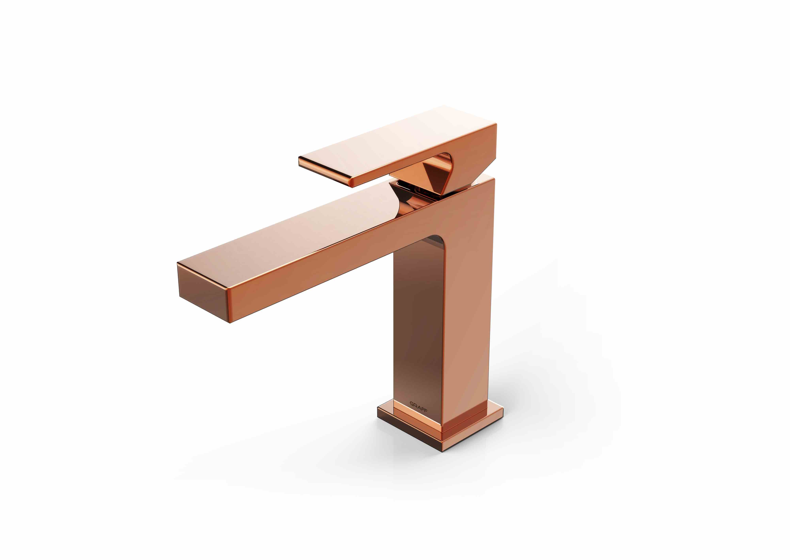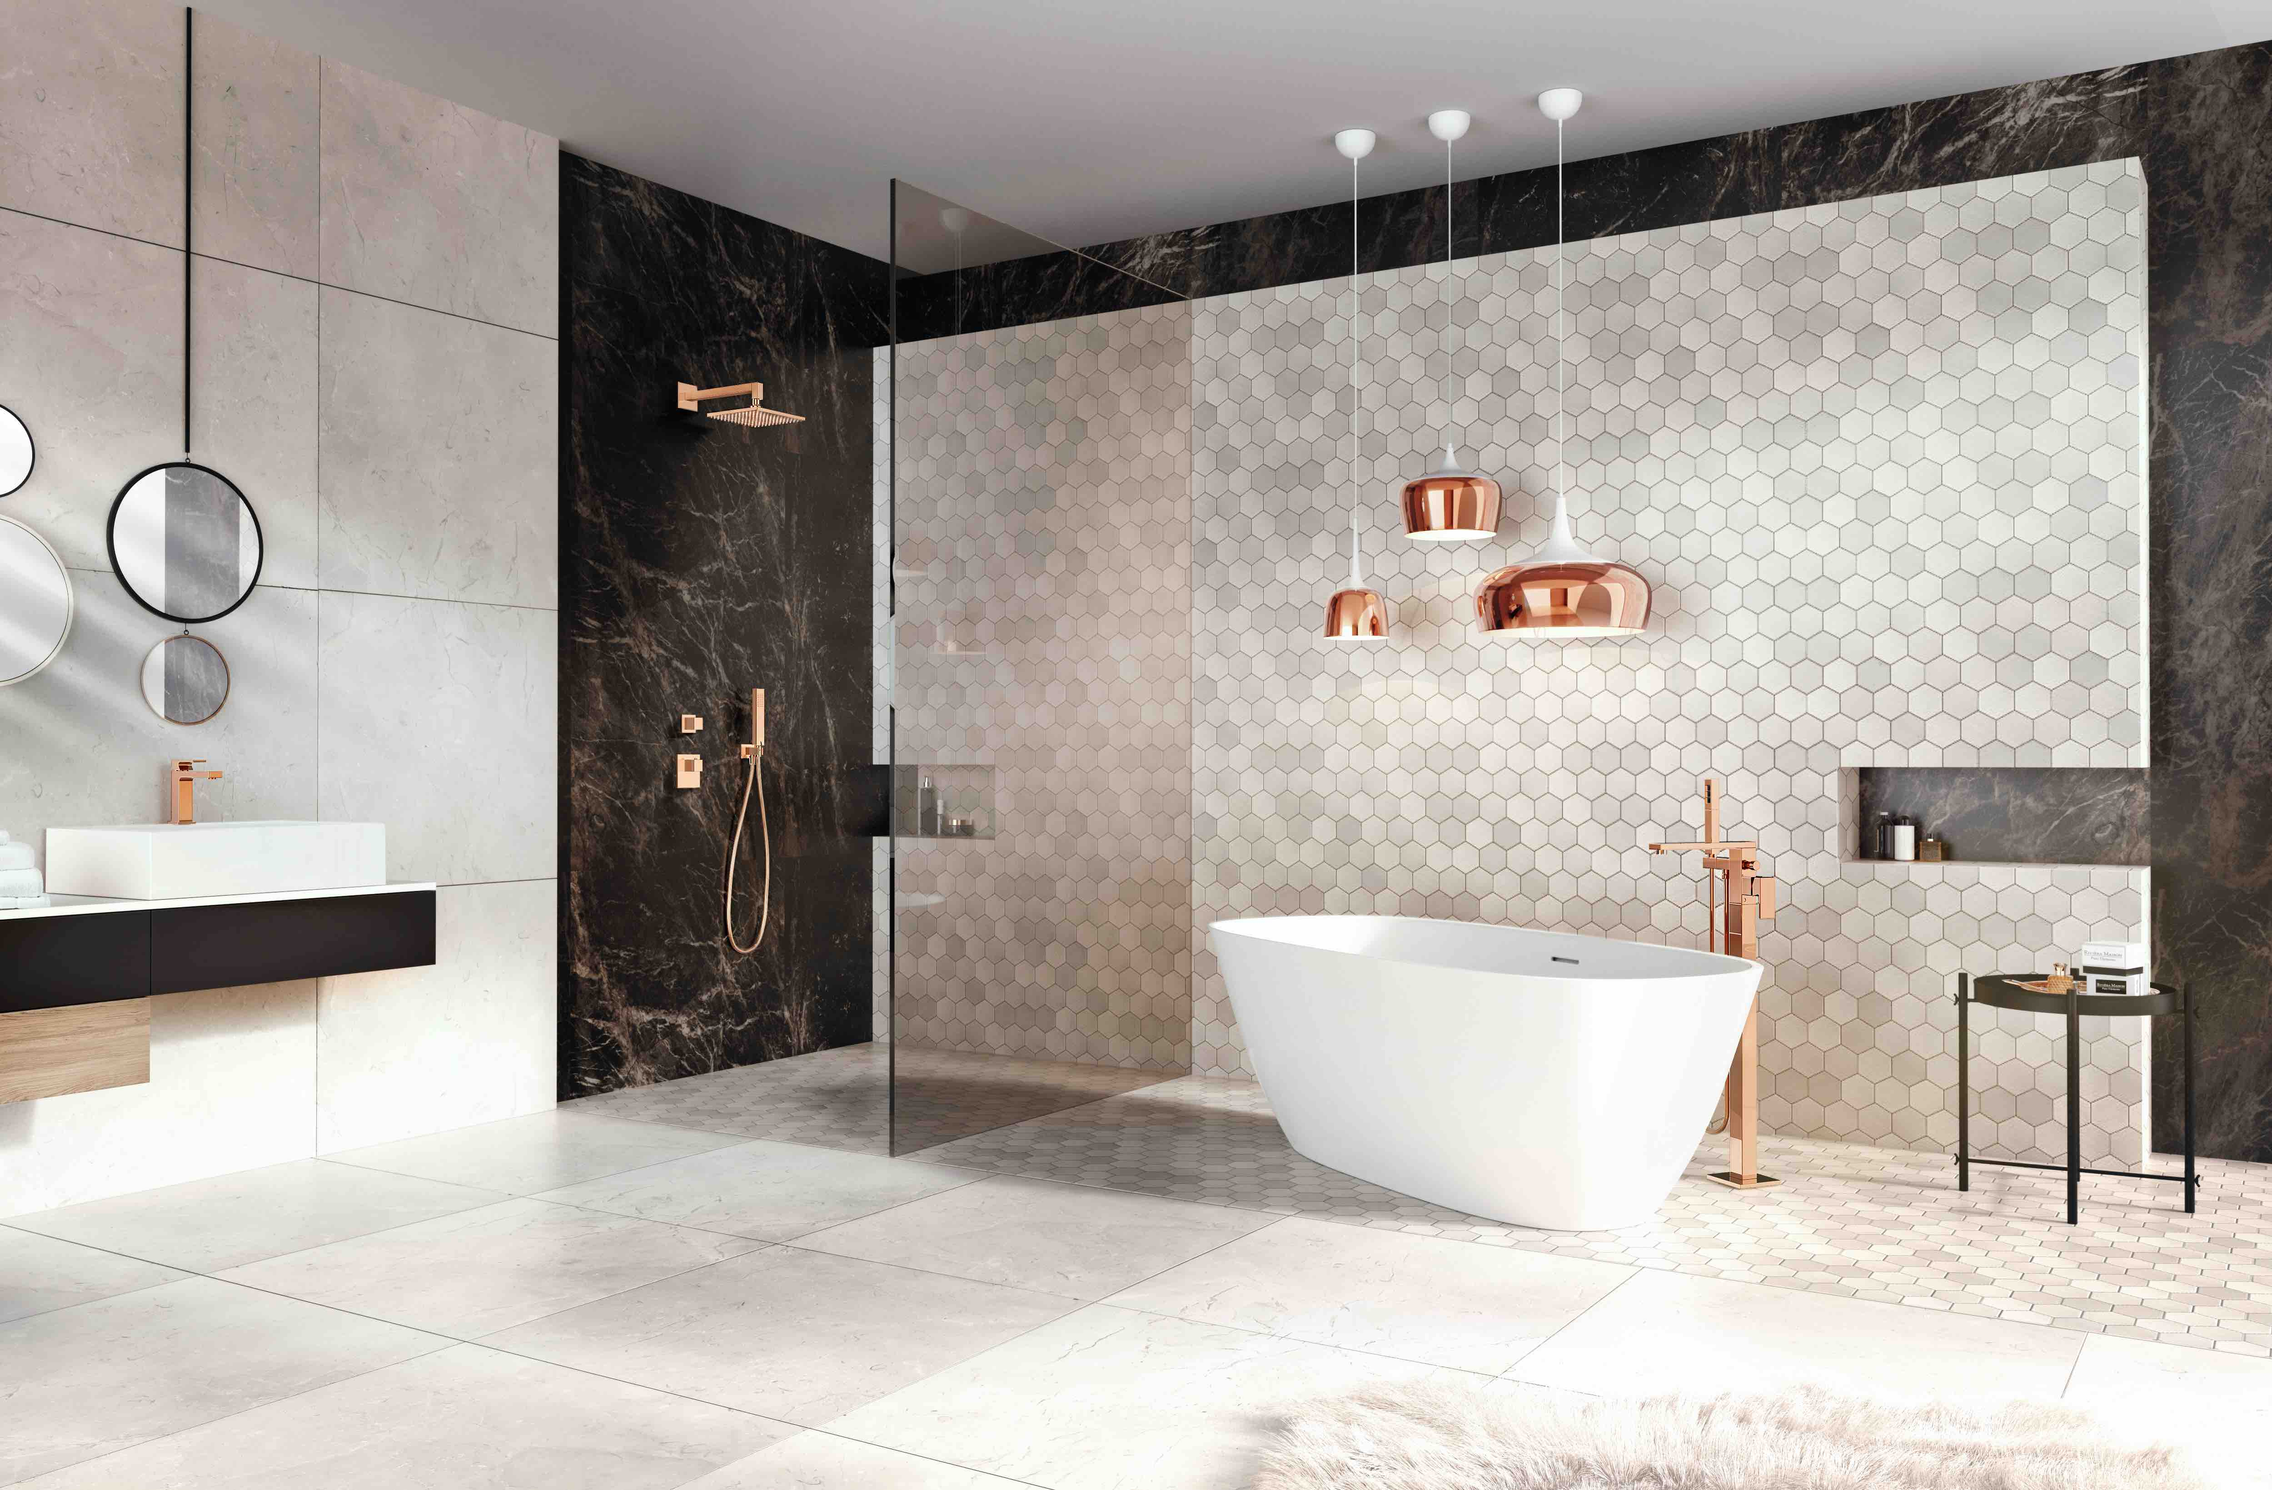

INCANTO faucet OR’osa
GRAFF EUROPE
Via Aretina 159, 50136 Florence - ITALY
Tel: +39 055 9332115,
fax: +39 055 9332116
email: info@graff-designs.com
www.graff-designs.com

For further information and high-resolution images
Press office:
tac comunic@zione milano|genova
tel +39 02 48517618 | 0185 351616
press@taconline.it | www.taconline.it

