ISH
17th - 21st March 2025
Frankfurt Trade Fair
Pad 3.1 Stand B 90

PRESS TOUR ON SITE
Monday 17th and Tuesday 18th March
hours 10:00 a.m. - 17:00 p.m.

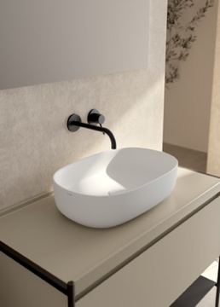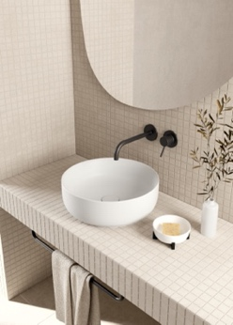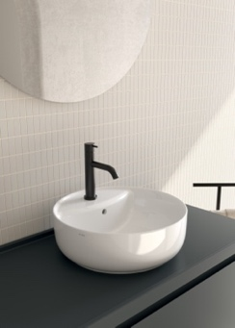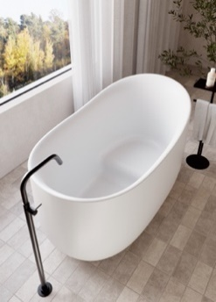
Washbasins KOI design Federica Biasi KOI Small bathtub design Federica Biasi

PRESS RELEASE
GLOBE AT ISH 2025: INNOVATION, SUSTAINABILITY AND CONTINUITY FOR A CHANGING MARKET
GLOBO renews its presence at ISH Frankfurt, the international reference event for the world of bathroom and furniture, with an exhibition that tells about evolution, research and sustainability. A 264 sqm exhibition in Hall 3.1, designed to involve visitors in a journey between innovation and responsible design, where every detail reflects the commitment of the company towards complete and reliable furnishing solutions.
GLOBO continues its consolidation path with strategic choices aimed at strengthening its position in the top market. Through selected materials and production processes with low environmental impact, presents at ISH 2025 an exclusive preview of the new products made in Italy, anticipating the future of living. The strategic evolution of the collections is a key investment for the Italian company, aimed at ensuring an ever more complete and high-performance range, combining technical and aesthetic excellence to meet current needs.
At ISH 2025, GLOBO confirms itself as a solid and reliable partner, able to guarantee continuity and availability in an increasingly demanding market. "Globo is experiencing an important evolution, both in the image and in the design approach", says CEO Andrea Gulinucci, "the aim is to strengthen its presence on the market with a contemporary and versatile aesthetic". "That’s why we invest in innovation and sustainability, constantly improving our collections and offering simple solutions always in line with the new needs of consumers.

PREVIEWS IN PRESS KIT
THE KOI, SOFT AND FUNCTIONAL WASHBASINS_Design Federica Biasi
Spotlights on the functional collection KOI, a line of contemporary washbasins that bears the signature of Federica Biasi and that offers a high compositional freedom: sophisticated shades, oval and round lines that transform every space in a manifesto of modern lightness, confirming the commitment of the company in the search for solutions always at the cutting edge. The fluid lines and soft edge enhance the elegance of ceramic while offering practicality and functionality. The neutral colour and the matt or glossy white surfaces of the RIFLESSI DI LUCE collection allow harmonious combinations with different furnishing solutions, enhanced by the possibility to have a round basin in the version with integrated tap top.
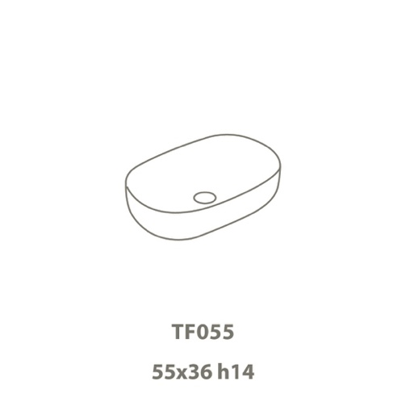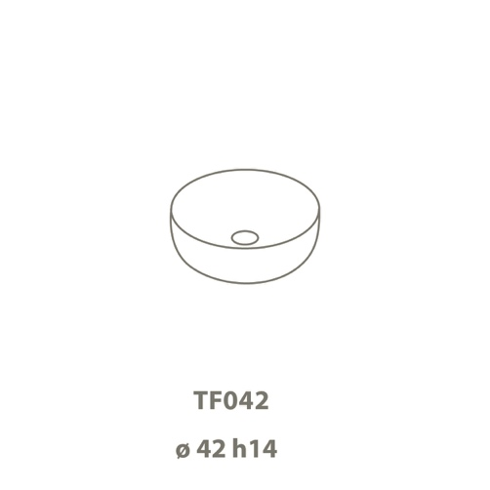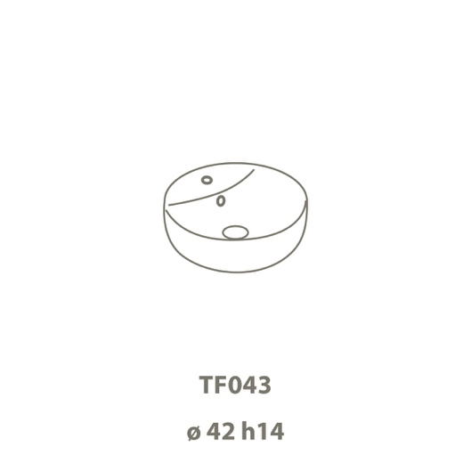

KOI SMALL: the essential bathtub_ Design Federica Biasi
Sinuous, essential and with a strong visual impact. KOI Small completes the collection of bathtubs designed by Federica Biasi, characterized by its pure and archetypal shapes created by the subtraction and the search for the perfect balance between design and functionality.
The line is compact and the design created to facilitate sitting and back support.
Made of LivingTec®, very durable material, measuring just 135 cm and it is available in matt white or in three matt colours from the BAGNO DI COLORE range (Castagno, Agata and Perla). A combination of purity of forms, high performance and contemporary aesthetics that perfectly and harmoniously integrates with the entire Globo catalogue, remaining faithful to the tradition of Made in Italy.

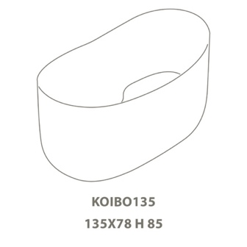

OTHER PREVIEWS YOU WILL FIND AT THE STAND:

BOB - An innovative furniture system
The new oval version of BOB, designed by angelettiruzzadesign, redefines bathroom furniture with a perfect mix of solidity and elegance. The fusion between the ceramic top and the steel structure creates a refined balance, enriched by storage elements and a drawer with integrated opening. An essential design that expresses personalization and innovation.

BONSAI - The missing compact washbasin
Bonsai, combines visual lightness and practicality with its oval or square design with thin edges. Made of ceramic to guarantee resistance and ease of cleaning, it is equipped with a mixer top, optimizing space and functionality. Perfect for minimalist environments, it harmoniously adapts to wood, marble or modern materials.

MATERIA - The essence of functional design
Designed by Federica Biasi, Materia enhances the ceramic through a shaped top that integrates with light and versatile structures. The version with structure is enriched by elegant wooden trays, creating a perfect balance between aesthetics and practicality. A project that celebrates ceramics in a contemporary way.

FORTY3 - Renewed design, maximum functionality

The Forty3 collection evolves with the new 55x36 cm version, designed to optimize space without sacrificing comfort. The CLEANSTORM NEW flushing system guarantees an essential aesthetic and a homogeneous surface, improving hygiene, efficiency and silence.

TILE - Elegance and versatility

TILE is a ceramic top that feels fluid and velvety, ideal for countertop washbasins. The refined shades perfectly match with the Globo colour range, while the ceramic ensures resistance, practicality and ease of cleaning. A minimal design that enhances the harmony of spaces.

I MAESTRI - Custom design for the contemporary bathroom

'I Maestri' wood furniture collection evolves with Linea, a new series that combines fine materials and fluted finishes for a sophisticated light and shadow effect. With suspended modules and versatile washbasin bases, it offers custom-made solutions for every space, combining design and functionality without compromise.
#TAConline #CeramicaGlobo #Press Office #Globo #DigitalPR #Bathroom furniture
Press and Digital PR:
TAConline
press@taconline.it
www.taconline.it

Contacts for press requests
Giulia Solari
press@taconline.it
+39 3201841476
Company:
CERAMICA GLOBO S.p.A.
01030 Castel Sant’Elia (VT) Italia
Loc La Chiusa
Tel. +39 0761/18731
ceramicaglobo.com
info@ceramicaglobo.com

Marketing Manager
Riccardo Bianchini
Tel. +39 0761 1873 533
riccardo.bianchini@ceramicaglobo.com

