ISH Press Release
Frankfurt, March 11 – 15, 2019
Pavilion 3.0, Stand F87

HYGEA, THE NEW SHAPE OF WATER
Inspired by natural elements, the new smart toilet by USPA is both eco-friendly and intelligent.

Freshness. Self-care. Design.
These are the elements at the base of the HYGEA project, the new smart toilet by USPA. It represents a real revolution in terms of comfort, hygiene, well-being and design that we’re certain will change our future from today.

HYGEA, in Greek mythology the goddess of health and hygiene, represents a hidden innovation for the bathroom.
Through an exploration of a new frontier of well-being and personal care, USPA has managed to radically transform the world of smart toilets: it has come up with an ideal balance in the combination of toilet seat, electronic bidet and toilet bowl.

HYGEA, in fact, embodies a new concept of a toilet with an integrated bidet. The electronic bidet component can be easily installed or replaced like a cartridge: it is placed in the toilet top-down and is entirely detachable from both the bowl and the seat.
“This project involved 54 people on seven teams, who over the course of 26 months of work have realized what we believe is the most functional and hygienic smart toilet on the market,” said Paolo Ravizzotti, CEO of USPA Europe.
“The goal we set for ourselves,” he went on, “was to pursue our work with passion every day to achieve excellence in each single component, which we would then bring together in a module structure that was practical and revolutionary.”

The innovative system conceived by USPA is composed of a toilet bowl, a mounting plate, an electronic bidet, a cover which contains the bidet and a toilet seat.
The electronic bidet is the beating heart of HYGEA. Designed with top-quality Korean technology, it has been studied to meet the needs of the most demanding customers.
The functions have been carefully selected and optimized to create the best experience possible. A stainless steel nozzle is used for personal hygiene, while air drying is effected by a high-efficiency device.
The “automatic draining of the tank” function and the anti-lime program ensure greater hygiene and reliability.

The principal functions include regulation of the water temperature and flow, positioning of the nozzle, a user memory program and an LED RGB light below the toilet bowl. All functions are distance-regulated by means of a convenient remote control operating by radio frequency; they can be controlled according to the needs to each individual user.
Other advantages of this new system are its ease of installation and maintenance. The assembly and disassembly mechanism renders it readily accessible and makes cleaning, replacement and repair work simple. Once inserted into place, the bidet component is always invisible and independent of the toilet seat: for this reason, if the bidet needs to be replaced or repaired, no inconvenience is created for users during the period of its removal. In addition, the electronic bidet can be purchased separately, thus allowing users to simply upgrade to future versions.

Particular care, finally, has been taken with regard to environmental concerns: the HYGEA flushing system uses only 3.5 liters of water; the plaster molds that give the toilet bowl its shape are manually produced, while the Higherglaze finish is easy to clean, thereby reducing the need for water and neutral cleaning detergents to a minimum.

The bowl is available in white, black, sand tan and turquoise, with either a gloss or satin finish. Upon request the HYGEA smart toilet can be custom colored.

IN THE IMAGES attached, THE WHITE AND the BLACK SATIN version

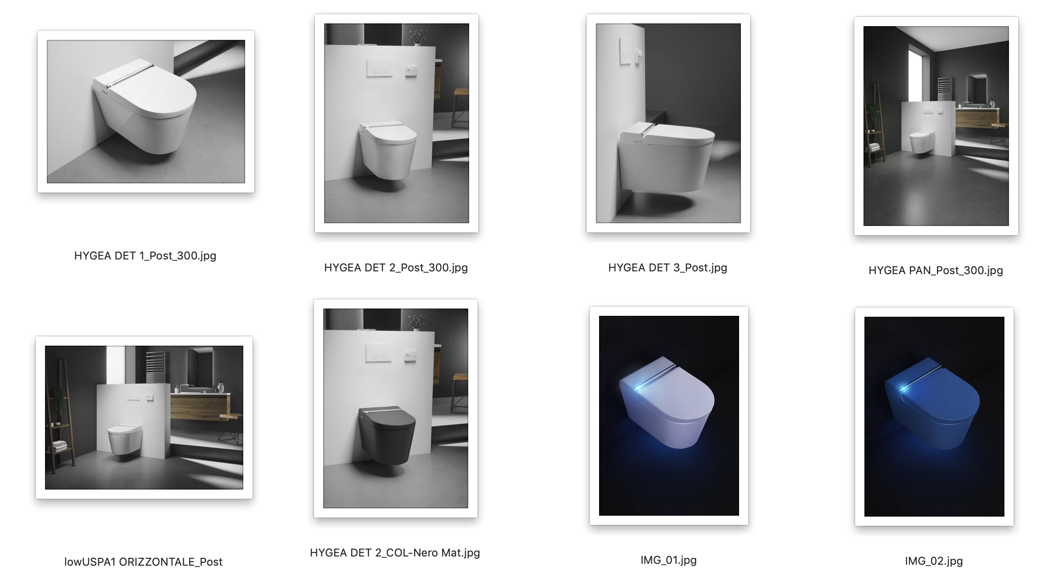

Editor’s note:

USPA Europe S.r.l. is an Italian company that specializes in the distribution of USPA electronic bidets and of smart toilets produced by the South Korean multinational IS Dongseo.
Thanks to its collaboration with some of the most important Italian toilet producers, the company is able to provide its customers the opportunity of blending unique Italian toilet design with the best of Korean technology. Products distributed by USPA Europe have already been installed in several luxury hotels and on yachts which seek products that are innovative and above all reliable. They are also used in several hospitals, thus confirming their important quality of total hygiene. Within the world of bathroom fixtures, USPA Europe strives to become the ideal and exclusive point of reference for those wishing to furnish their bathrooms with products able to guarantee the maximum of technological innovation, reliability, quality and functionality.
Today the electronic bidet is an essential feature of Asian culture. Indeed it is also known as the Japanese bidet, in honor of the country that made it famous. In Italy as well it has become an indispensable accessory. USPA Europe specializes in the distribution of this fixture, which is destined to change the culture and daily hygiene of Europeans. The company offers a complete range of electronic toilets with bidet and smart toilet functions that guarantee the highest standards of hygiene and comfort.
Ufficio Stampa Italia
tac comunic@zione
Milano| Genova
www.taconline.it press@taconline.it
T +39 02 485171618

Uspa Europe S.r.l.
Corso della Vittoria, 14
28100 Novara
Tel. +39 0321 030449
info@uspa.eu www.uspa.eu

