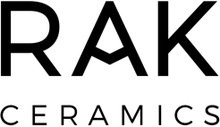

Leonardo de Muro
Vice President in International Business Development, Marketing and Communication of RAK Ceramics
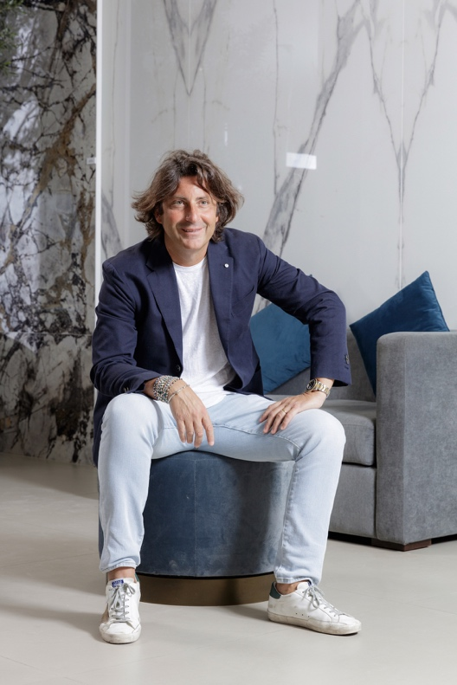
In July 2018, Leonardo de Muro joined RAK Ceramics as the Vice President of International Business Development, Marketing, and Communication at RAK Ceramics PJSC. Leonardo is responsible for overseeing RAK Ceramics’ marketing, product developments and collaborations as well as developing marketing strategies to enter new markets.

Prior to starting his role with RAK Ceramics, Leonardo was Chief Sales Officer & Marketing at TAGINA, a leader for 50 years in the high-end ceramic floor and wall tiles sector.

Having worked across several reputed ceramics brands in Italy and Turkey, including Imola Ceramica, Kalebodur and Emilceramica at executive level. Leonardo is well-versed in sales strategy, marketing communications, and digital transformation leadership.

Leonardo holds a postgraduate degree in Marketing and Marketing Management from the Alma Mater Studiorum - University of Bologna in Italy and Foreign Languages ​​and Literature from the University of Parma in Italy.

