Abdallah Massaad
Group Chief Executive Officer of RAK Ceramics
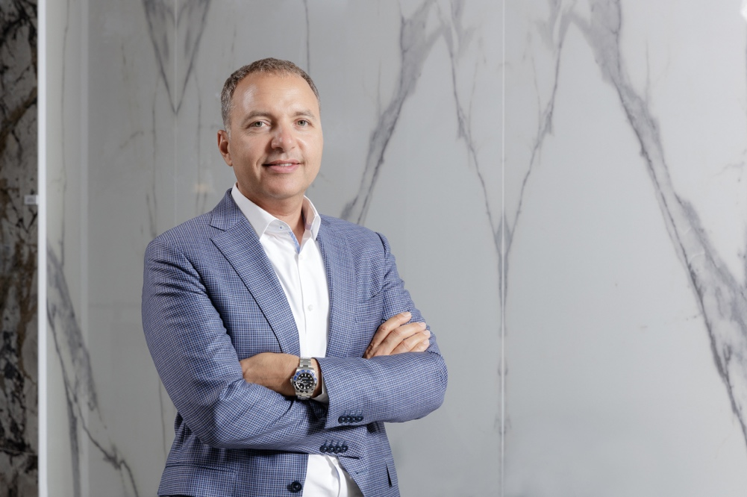

In June 2012, Abdallah Massaad was appointed Group Chief Executive Officer at RAK Ceramics and his tenure with the company began in 2004. Abdallah is also a representative on the board and management of several subsidiaries of the company. Under Abdallah’s leadership, RAK Ceramics has grown to become a global player on the world stage of ceramics manufacturing.

With over 25 years of experience in ceramics manufacturing, sales management, product marketing and business leadership, Abdallah holds a wealth of knowledge and insight in the respective fields and is instrumental in helping companies engage in the forward and backward integration of the ceramics supply chain. He also has highly developed business leadership skills in national and international markets.

Prior to RAK Ceramics, Abdallah Massaad was General Manager and Area Sales Manager at International Ceramics Company SARL (ICC) Lebanon. He also holds a post graduate qualification in Management ‘DEA in Business Administration’ and an undergraduate degree ‘Maitrise in Business Administration – Marketing’ from Université Saint-Esprit de Kaslik, Lebanon. He is fluent in Arabic, French and English and also speaks basic German.

