PRESS RELEASE 2020

TOPAZ, AN ART DECO-INSPIRED COLLECTION BY GRAFF
Offered in Vintage Brushed Brass (VBB) with an epoxy finish and Gunmetal (GM) with a living, transforming finish

GRAFF’s Topaz collection is inspired by Art Deco design, with an unmistakable hexagonal handle and spout base. Designed by G+ Design Studio, Topaz reveals itself as being the narration of a project, a strong statement with a precise concept -no superfluous details, no redundant movement, only a stylistic reinterpretation in a contemporary way.

All the elements of the Topaz collection are characterized by rhythmic aesthetics, made up of pure geometric shapes and enriched by stylistic details. The coordinated accessories define the design for a harmonic and functional environment.
All faucets are made from an internally-emptied solid brass block. Due to this manufacturing technique, the jet is more full-bodied than normal and provides a unique importance and proportion to the tap. The new lever features an octagonal section that recalls the collection’s theme, full-bodied with an ergonomic grip. The new spout is lower while still maintaining the classic, geometric shape.

The finishes portrayed in the photos are Vintage Brushed Brass (VBB, an epoxy finish similar to powder coating), Gunmetal (GM, a living finish) and Polished Chrome (PC, a galvanic finish).

The Vintage Brushed Brass finish showcases a vintage brass base with a detailed brushing finish that varies from yellow to dark brown.
The powder coated finishes are developed with a dry process called electrostatic spray deposition in which a fine powder is applied with a gun on a metal base and then dried at high temperatures. Powder coated products are resistant to moisture and ultraviolet light and have a long service life.

In addition to giving a pleasant texture, the powder coating treatment reduces the risk of scratches, chips, abrasions, corrosion and other signs of wear.
Vintage Brushed Brass is an epoxy liquid coating with properties similar to powder finishes. All GRAFF brushed finishes are completed through hand application with an intense eye for detail.

- Topaz faucets and fittings, produced with brass containing very low nickel and lead content, are made in compliance with drinking water regulations and comply with the most restrictive criteria for the protection of health and the environment.

The Gunmetal finish is transformative and unique to each environment. This finish requires special care and attention. Designed to change in appearance over time, Gunmetal develops a unique warmth and character. Gunmetal and Gunmetal Distressed are completed with an industrial waxing process which gives it a more natural appearance and a warmer, velvety texture. If not treated with wax, Gunmetal and Gunmetal Distressed tend to lighten especially around the edges.

Availability: September 2020

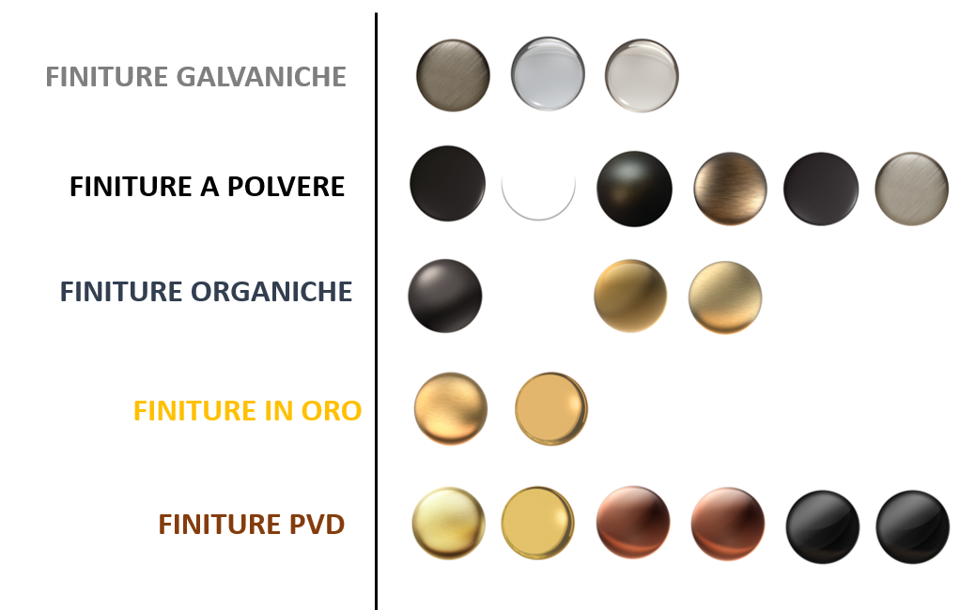

Collection: Topaz
Finish: Polished Chrome
Design: G+Design Studio
Price for widespread set in Polished Chrome: starting from £ 762,00 + VAT (only UK market price)
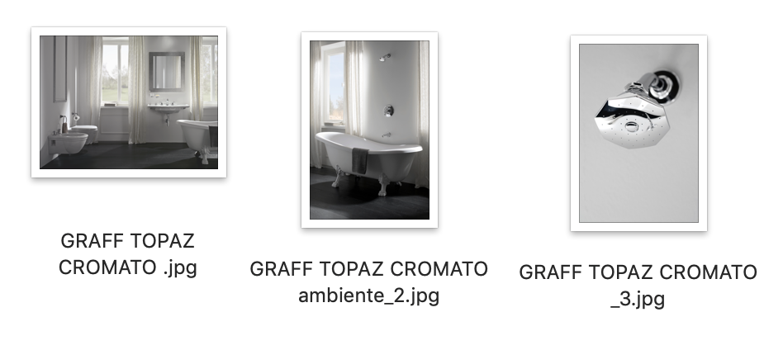

Collection: Topaz
Finish: VBB (Vintage Brushed Brass)
Design: G+Design Studio
Price: (in Vintage Brushed Brass): starting from £ 1028,00+VAT (only UK market price)

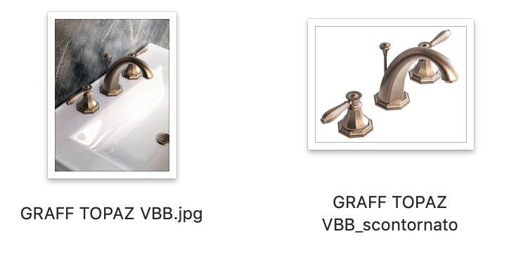
GRAFF EUROPE
Via Aretina 159, 50136 Florence - ITALY
Tel: +39 055 9332115,
fax: +39 055 9332116
info@graff-designs.com
www.graff-designs.com

PRESS OFFICE
tac comunic@zione milano|genova
tel +39 02 48517618 | 0185 351616
press@taconline.it | www.taconline.it

Collection: Topaz
Finish: Gunmetal
Design: G+Design Studio
Price: (in Gunmetal): starting from £1028,00+VAT (only UK market price)
