FOR IMMEDIATE RELEASE

GRAFF’S® NEW BRUSHED GOLD VINTAGE COLLECTION EMBRACES INDUSTRIAL STYLE
New collection melds contemporary styling with vintage aesthetics

December 2018 — GRAFF®, manufacturer of contemporary precision-engineered kitchen and bath products, has revealed the design of its latest collection, Vintage, to the European marketplace. The collection emulates the best of the industrial design paradigm, perfectly suited to outfit metropolitan environments known for their loft style.

The Vintage Collection draws inspiration from the design of classic fire hose nozzles, pairing a modern spout with bold handles. Each element, from the rounded brim at the spout’s top to the undulating handles complete with carefully designed cut outs, resembles the traditional forms of the fire house featured in the historic Chicago Fire Department logo. The design acts in tribute to the brave members of the Chicago Fire Department and Illinois Fire Safety Alliance, who have recognized the product. “We are thankful for GRAFF’s support and homage to Chicago,” says Philip Zaleski of the Illinois Fire Safety Alliance.

The Vintage Collection enriches bathroom suites through its elevated design. The G+Design Studio honed-in on the collection’s handle design to create a beautiful, practical and ergonomic solution that facilitates easy use. The collection offers a choice of circular or linear lever handles (with a knurled accent for added allure) for deck-mounted and wall-mounted installations. The two-hole and single-lever faucets feature an internal progressive cartridge that makes it possible to regulate water temperature while maintaining constant pressure. This system reduces hot water waste.

The Vintage Collection is offered in nineteen contemporary finishes: Polished Chrome, Polished Nickel, Brushed Nickel, Unfinished Brass, Unfinished Brushed Brass, White, Architectural Black, Steelnox®, Olive Bronze, Vintage Brushed Brass, Gunmetal, Gunmetal Distressed, Gold and Brushed Gold. For this new series, the handles are available with a two-tone finish crafted with black accents: Chrome with Black, Polished Nickel with Black and the striking combination featuring Brushed Gold with Black.

GRAFF is the first company in the world to have adopted the strictest international standards to eliminate any residual lead from the water supplied. The Vintage faucets are therefore eco-friendly and guaranteed for 5 years.
About GRAFF:
Headquartered in Milwaukee, Wisconsin, and with locations throughout Europe, GRAFF is recognized globally for its trend-setting products and unique vision. Supported since 1922 by extensive plumbing and hardware manufacturing experience, GRAFF offers a wide range of contemporary, transitional and traditional styling. GRAFF’s commitment to creating cutting-edge, premium-quality fixtures is evident in each and every product. GRAFF employs more than 1,000 dedicated professionals and has control over the full production process, making it truly a vertically integrated manufacturer.

For more information about GRAFF, visit www.graff-designs.com or www.facebook.com/grafffaucets

#Graff #brushedgold #gold #vintage

Graff VINTAGE
Design: G+Design Studio
The collection offers a choice of circular or linear lever handles in nineteen contemporary finishes
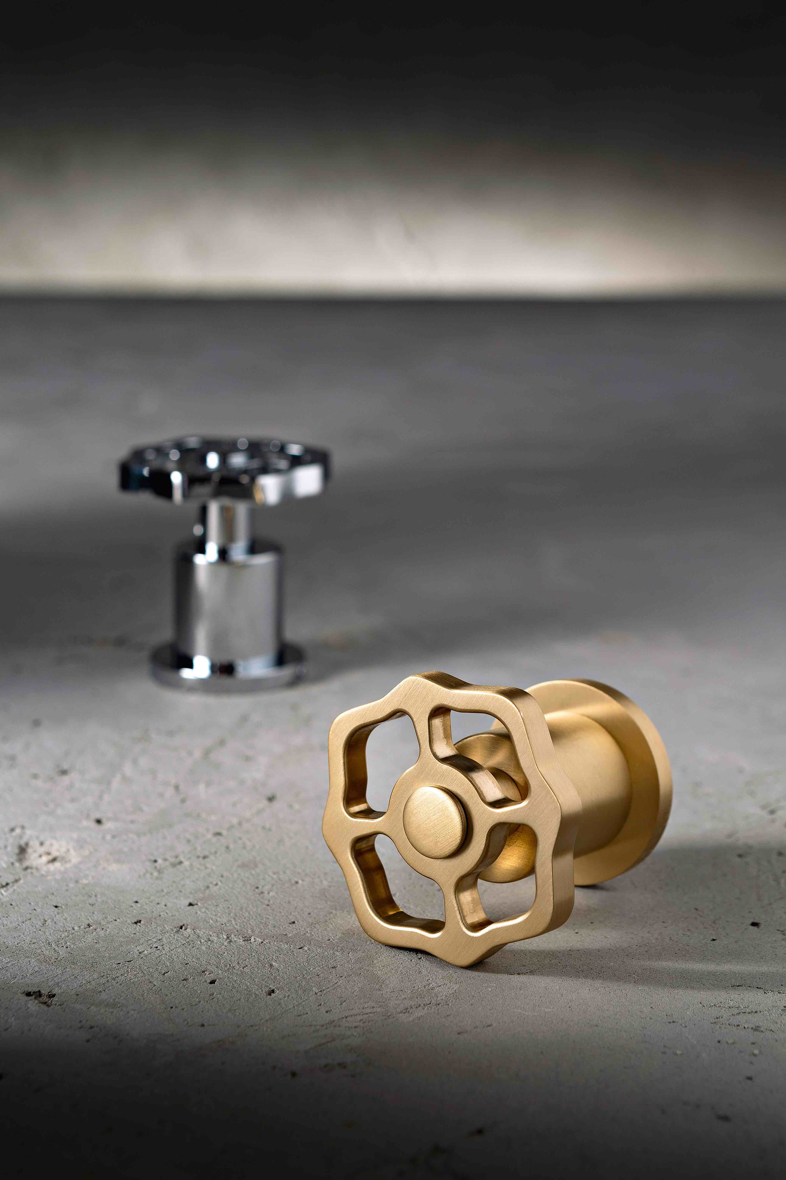

Finishes
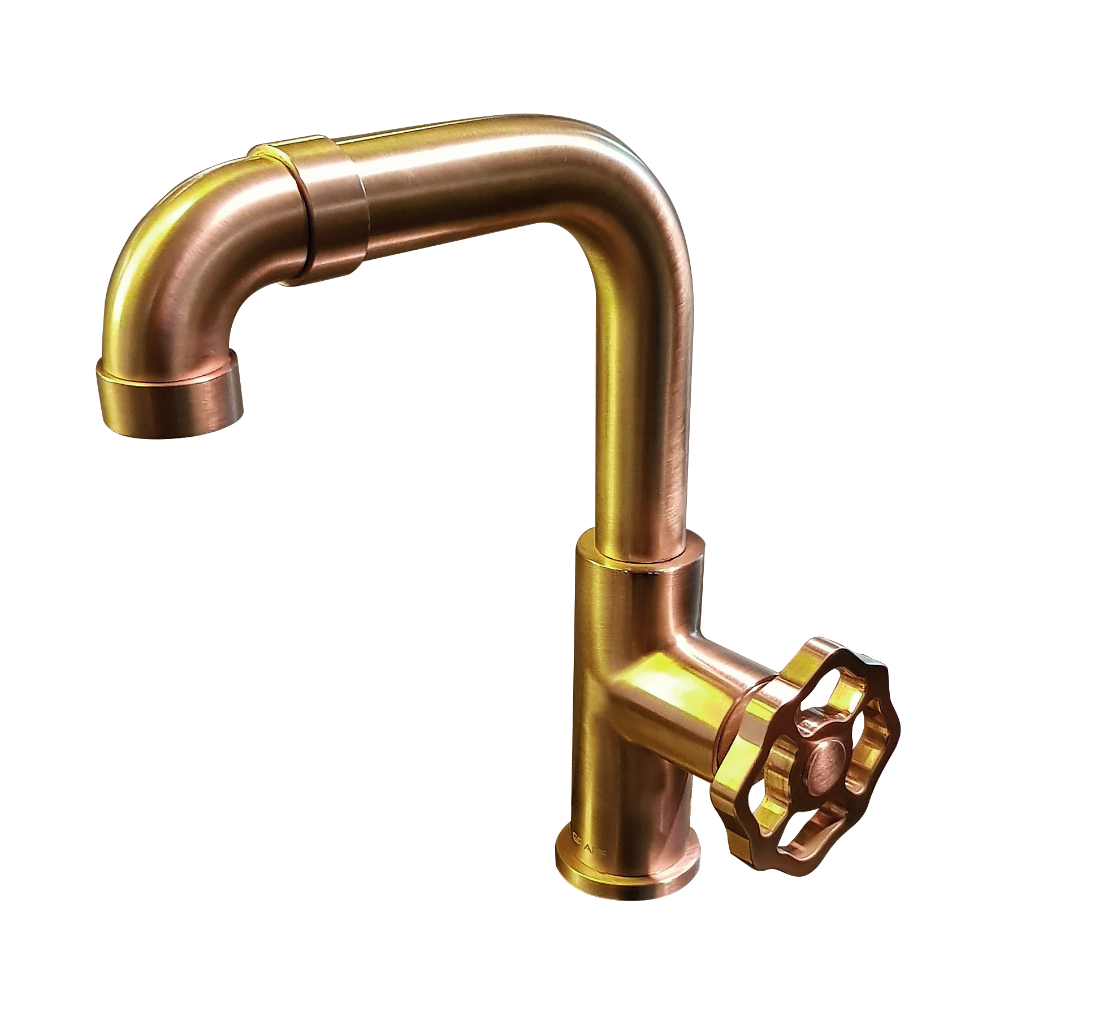
Vintage brushed gold circular leve

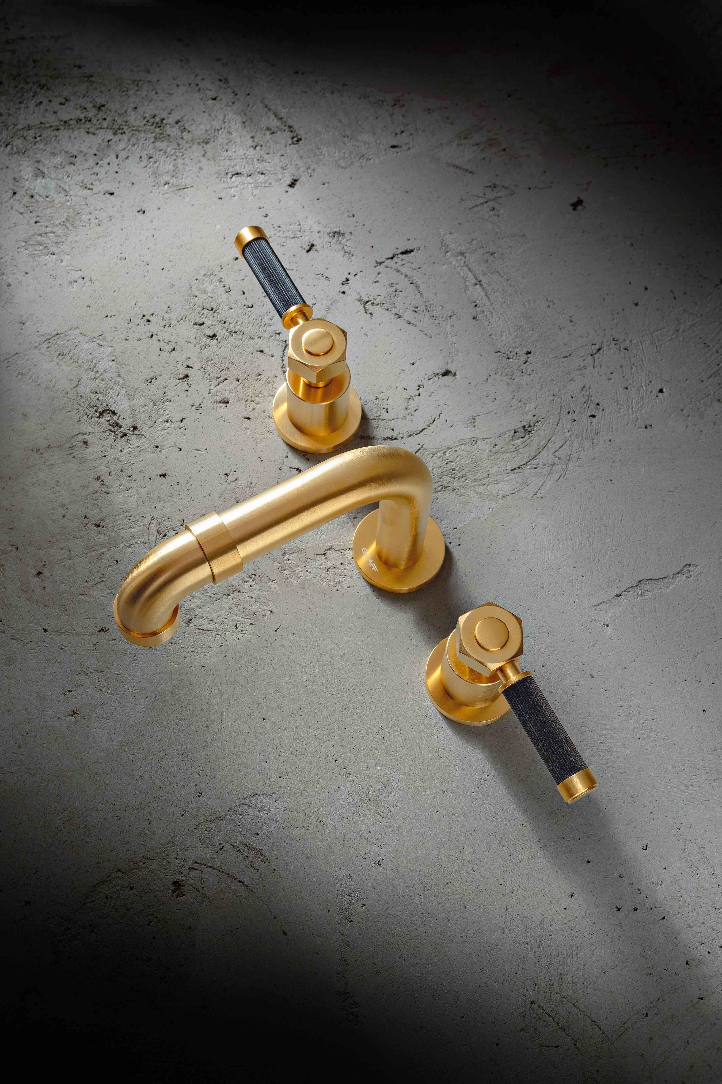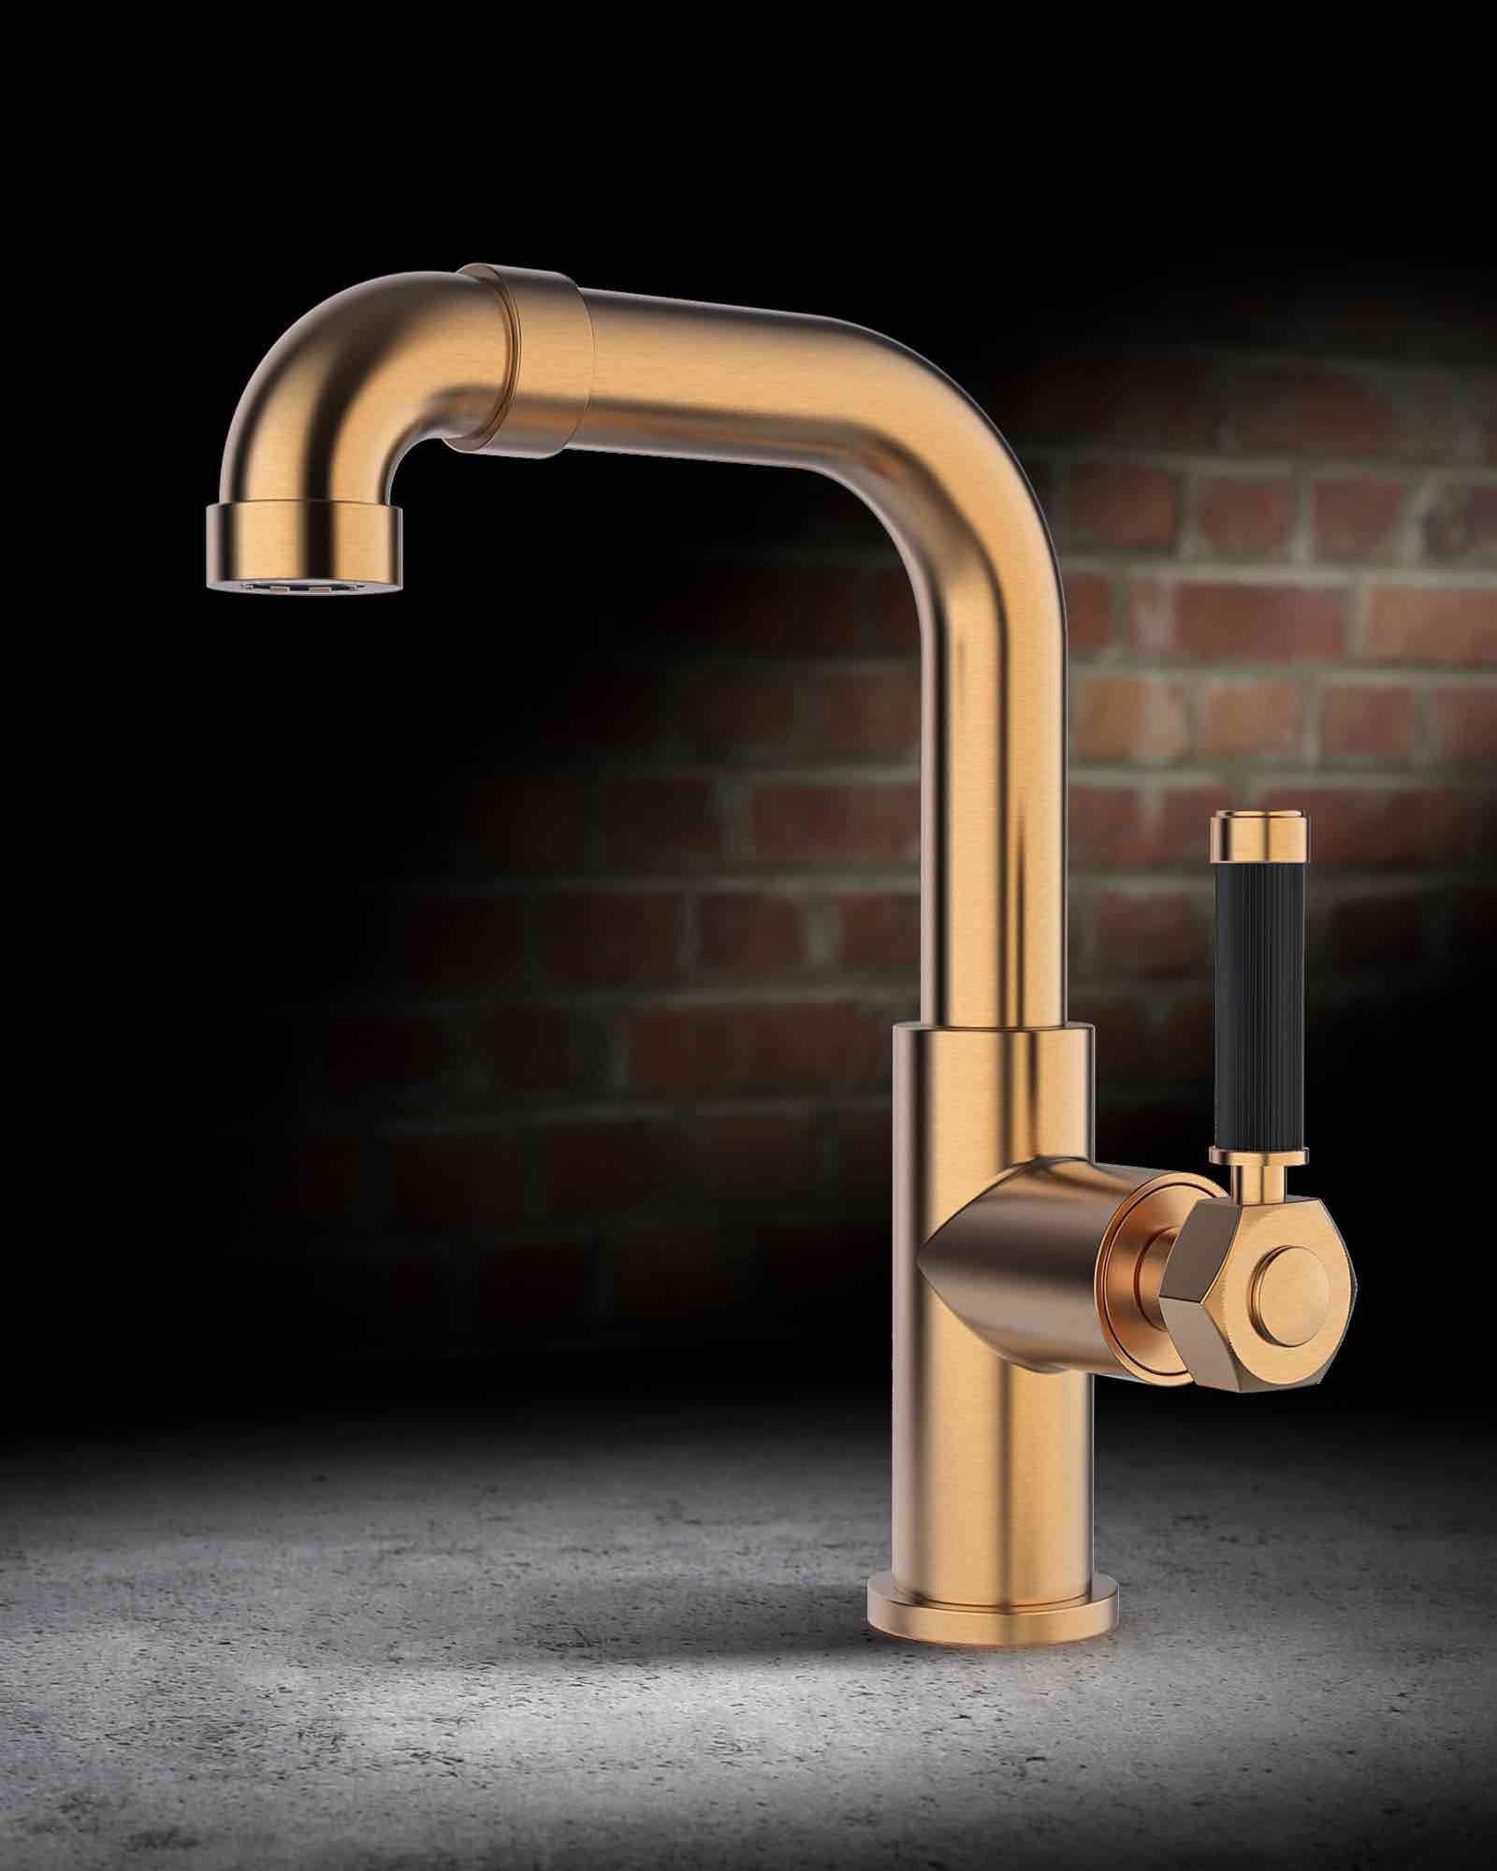

Vintage brushed gold /black Vintage brushed gold /black 1 hole
3 holes linear leves circular leve

For further information and hi-resolution images
Press office:
tac comunic@zione milano|genova
tel +39 02 48517618 | 0185 351616
press@taconline.it | www.taconline.it
GRAFF EUROPE
Via Aretina 159/1 50136 Florence - ITALY
Tel: +39 055 9332115,
fax: +39 055 9332116
email: info@graff-designs.com
www.graff-designs.com

