PRESS RELEASE

REVOLUTION®: a new starting point, the reversal of an order. When Ceramic meets solid surface

SDR Ceramiche presents a revolutionary project to challenge the bathroom market.

REVOLUTION® collection is an absolute novelty in the sanitary ceramic sector. The brand new collection of Pan and Bidet in Livin-Stone® (solid surface) designed by Luca Papini is complete with all the products for the bathroom (Bath-tube, washbasin, including equipped shelves).

The real novelty of the collection lies in the material: for the first time a line of sanitary ware is produced in Livin-Stone® (solid surface), an antibacterial material designed to meet high standards of technological quality, environmental impact and hygiene never achieved before.
The edges of the toilet and bidet are "sharp edge" - not round as in the classic ceramic sanitary ware - enhance the unique design of REVOLUTION®.

The perfect surfaces, without irregularities, the cleanness of the shapes, the thicknesses and its soft lines give the collection a timeless contemporaneity. The bidet is completely in solid surface while the toilet has a body in Livin-Stone® and the internal part in ceramic thanks to a patented particular joint, both perfectly coordinated.

REVOLUTION®, covered by Patent (Patent Pending), has passed all the technical tests of mechanical resistance necessary to ensure the same reliability of traditional products.

“REVOLUTION® speaks about a radical transformation, bringing the world of bathroom use to the ceramic toilet and bidet to the new point of view of the solid surface”. Luca Papini declares.
According to the designer, revolutions, courageously, mark a new starting point: this is what SDR Ceramiche wanted to undertake in the world of the bathroom

REVOLUTION® It is a full body product, currently available in the following colors: - Cotone - Camelia - Avio – Aloe.
Alongside the collection, there is a line of ceramic console with drawer that is characterized by the soft graphic sign, the curve of the basin inscribed in a rectangle. The Cotone white color of the console gives greater emphasis to the 2 drawers also declined in 4 colors.
The ergonomics of the lines and the lateral support base give the new console a new mood and a contemporary interpretation of the basin area.

SDR Ceramiche world
A place full of inspirations and contaminations of languages that is not limited only to functionality, but becomes an integral part of the home without interruption. An environment in which to express yourself and carve out precious moments. The contemporary bathroom is all this and much more. SDR Ceramiche philosophy focuses on the creation of a design product that can meet the different tastes of the public while remaining consistent with its own history and concept.
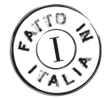

Image: REVOLUTION® by SDR Ceramiche
Sanitary ware in Camelia finishing - Production year: 2018

Livin-Stone®: solid surface. Non-toxic, antibacterial, inert, hypoallergenic and fire retardant. Livin-Stone®, in addition to offering high functional and aesthetic performance, is easily recoverable and recyclable, thus returning to the so-called "eco-compatible" materials. Its solid and homogeneous surface is absolutely free of porosity and extremely smooth, transmitting great aesthetic sense and purity. Livin-Stone® is easy to clean, does not become yellow and its color does not lose tone over time.

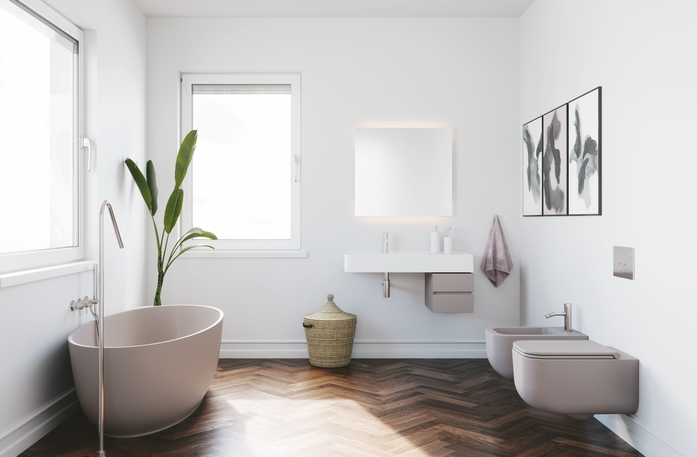
PRESS OFFICE:
tac comunic@zione
Milano - Genova (Italy)
ph. + 39 02 48 51 76 18
f. + 39 0185 35 16 16
press@taconline.it
www.taconline.it
SDR Ceramiche s.r.l.
loc. Quartaccio
01034 Fabrica di Roma
Viterbo - Italy
ph. +39 0761 598469
info@sdrceramiche.it
www.sdrceramiche.it

