PRESS RELEASE
SEPTEMBER 2018

GRAFF OFFERS NEW HARLEY COLLECTION IN THE BRUSHED NICKEL FINISH

2018 - Harley, the faucet collection using an industrial aesthetic with details nostalgic of the all-American icons, is now available in the warm Brushed Nickel finish.

Conceptualized by GRAFF’s G+Design Studio, the faucet’s handle offers a unique eclecticism and adaptability to contemporary and technical environments. Each element of the faucet was carefully considered, crafted to prevent slipping and prompt ease of use. An ergonomic shape serves as the basis for this design, allowing for a variety of grip techniques to be utilized. The faucet’s internal workings also create a seamless user experience, with the progressive cartridge.
In the single lever, in fact, the internal progressive cartridge allows to regulate the temperature from cold water to mixed water and hot water by simply turning the handle, keeping the flow constant, thus avoiding the waste of hot water at the minimum opening of the tap.

The Harley collection includes one, two, or three-hole versions of the sink, the bathtub and the bidet mixers; wall, floor or deck-mounted models, and a linear lever option, also knurled for a user-friendly handle. The bathtub free-standing filler stands out for its elegance and slim shape. The collection additionally includes wall-mounted items intended for shower areas that are compatible with the M-series and Uni-box concealed systems.

The Harley collection is available in several elegant finishes, including Onyx - a PVD finish that is as attractive as it is durable.

GRAFF is the first company in the world to have adopted the strictest international standards to eliminate any residual lead from the water supplied by its faucets. Harley is eco-friendly and guaranteed for 5 years

GRAFF HARLEY technical details
Design: G+Design Studio
Finishes: Polished Chrome, Gunmetal, Brushed Nickel, Polished Nickel, Unfinished Brass, Unfinished Brushed Brass, Steelnox®, Onyx, Olive Bronze, Black, White, Vintage Brushed Brass, Brushed Gold and Polished Gold.

Harley, wall-mounted washbasin mixer in Brushed Nickel finish
Brushed Nickel is obtained through a galvanic process and features a very pleasant texture to the touch. It’s a contemporary finish with an industrial, refined look.

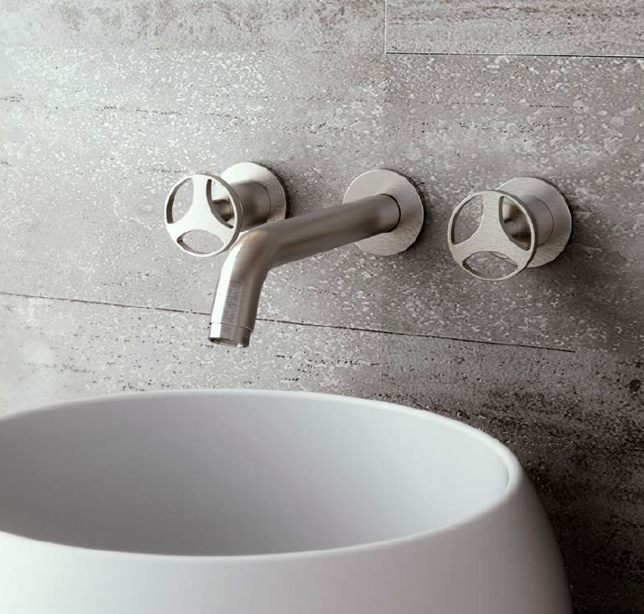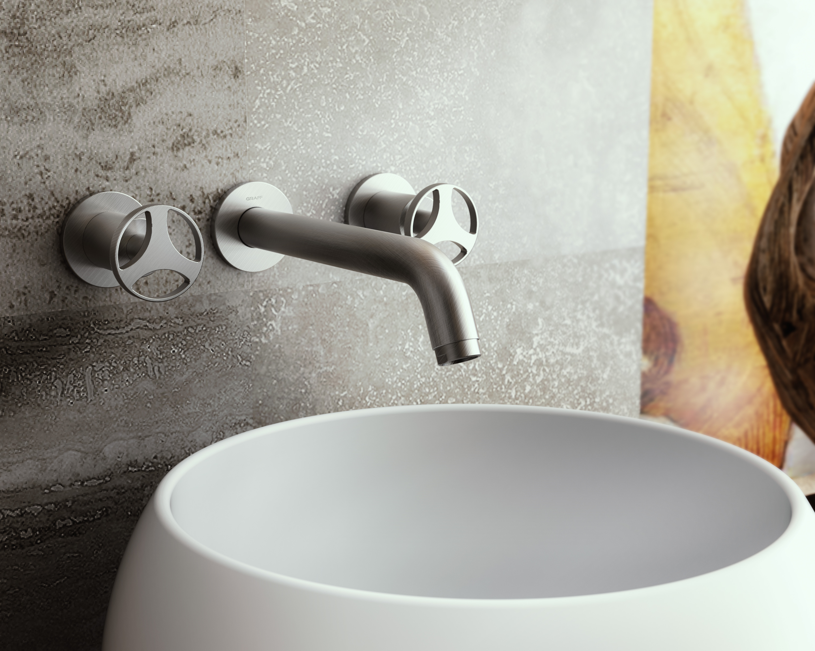

Harley thermostatic wall-mounted shower set in Brushed Nickel
Harley collection offers several wall-mounted items for the shower, including the ones compatible with the M-Series and Uni-box concealed systems.

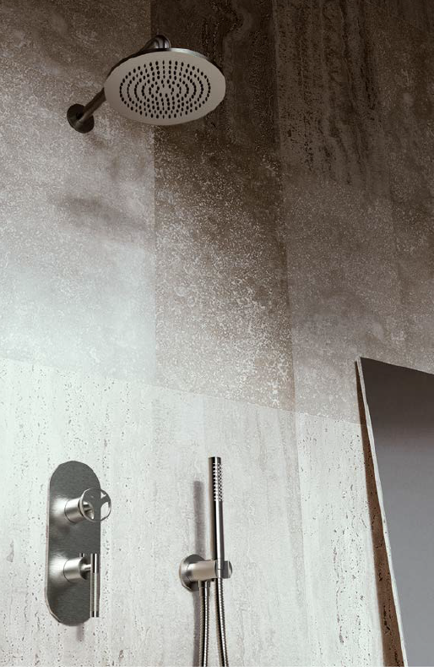

GRAFF EUROPE
Via Aretina 159, 50136 Florence - ITALY
Tel: +39 055 9332115,
fax: +39 055 9332116
email: info@graff-designs.com
www.graff-designs.com

For further information and high-resolution images
Press Office:
tac comunic@zione milano|genova
tel +39 02 48517618 | 0185 351616
press@taconline.it | www.taconline.it

