Press kit autumn-winter 2017

GRAFF’s Latest Innovation,
the Tephi Bathtub, wins the prestigious #MetropolisLikes Award, 2017

Tephi, GRAFF’s Sleek-Stone® bathtub, has been honored for its contemporary design and artistic quality as a 2017 #MetropolisLikes product. The awards program celebrates the best in design at the annual NYCxDESIGN festival in New York, inclusive of products showcased at International Contemporary Furniture Fair (ICFF). The innovation, defined by GRAFF’s new Sleek-Stone® bath program, emphasizes the brand’s artistic and creative sensibility, and underscores GRAFF’s commitment to the creation of innovative bathroom systems.

A kaleidoscope trophy, designed to symbolize the ever-changing world of design, was presented to GRAFF President and CEO, Ziggy Kulig, in celebration of the accolade. In reaction, Kulig commented: “This recognition confirms GRAFF’s constant dedication to go beyond the boundaries of bathroom design and to challenge the existing architecture paradigms.”

Tephi’s design reflects a modern style that facilitates dialogue between end-users and designers. The bathtub is crafted entirely from Sleek-Stone®, a new, technologically advanced material that combines dolomite marble with a unique resin, to create a solid compound that has the same appeal as natural stone. Sleek-Stone® is warm to the touch, with a unique and luxurious smoothness that offers an exclusive and elegant experience in the bathroom. Its stain and UV resistant properties make the surfaces easy to clean, with minimal maintenance.

Designed by G+Design Studio, Tephi embodies a sleek, modern style. Geometric lines, which recall monolithic forms, characterize both the bathtub and the washbasin. Each piece can be combined with GRAFF faucet models, especially with the Phase and Sade collections. Tephi is available in gloss or matte white finishes.
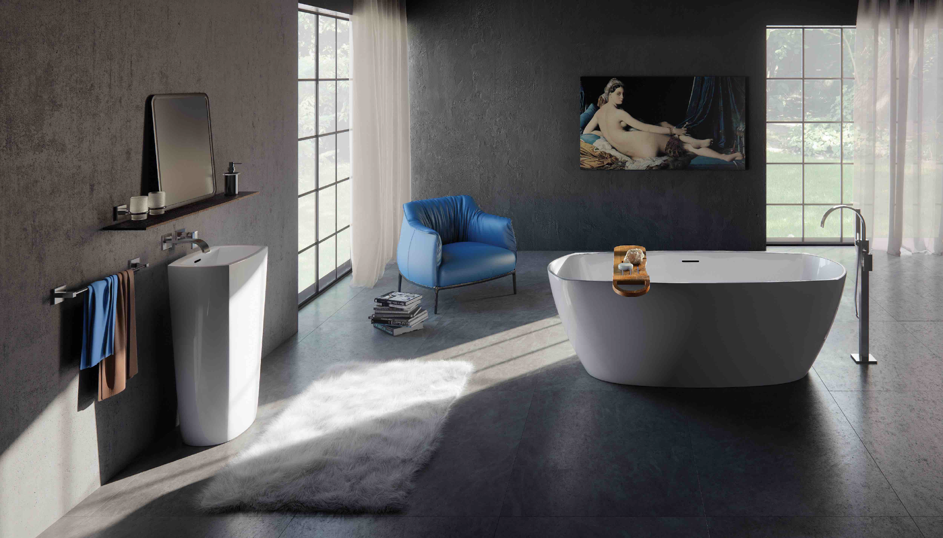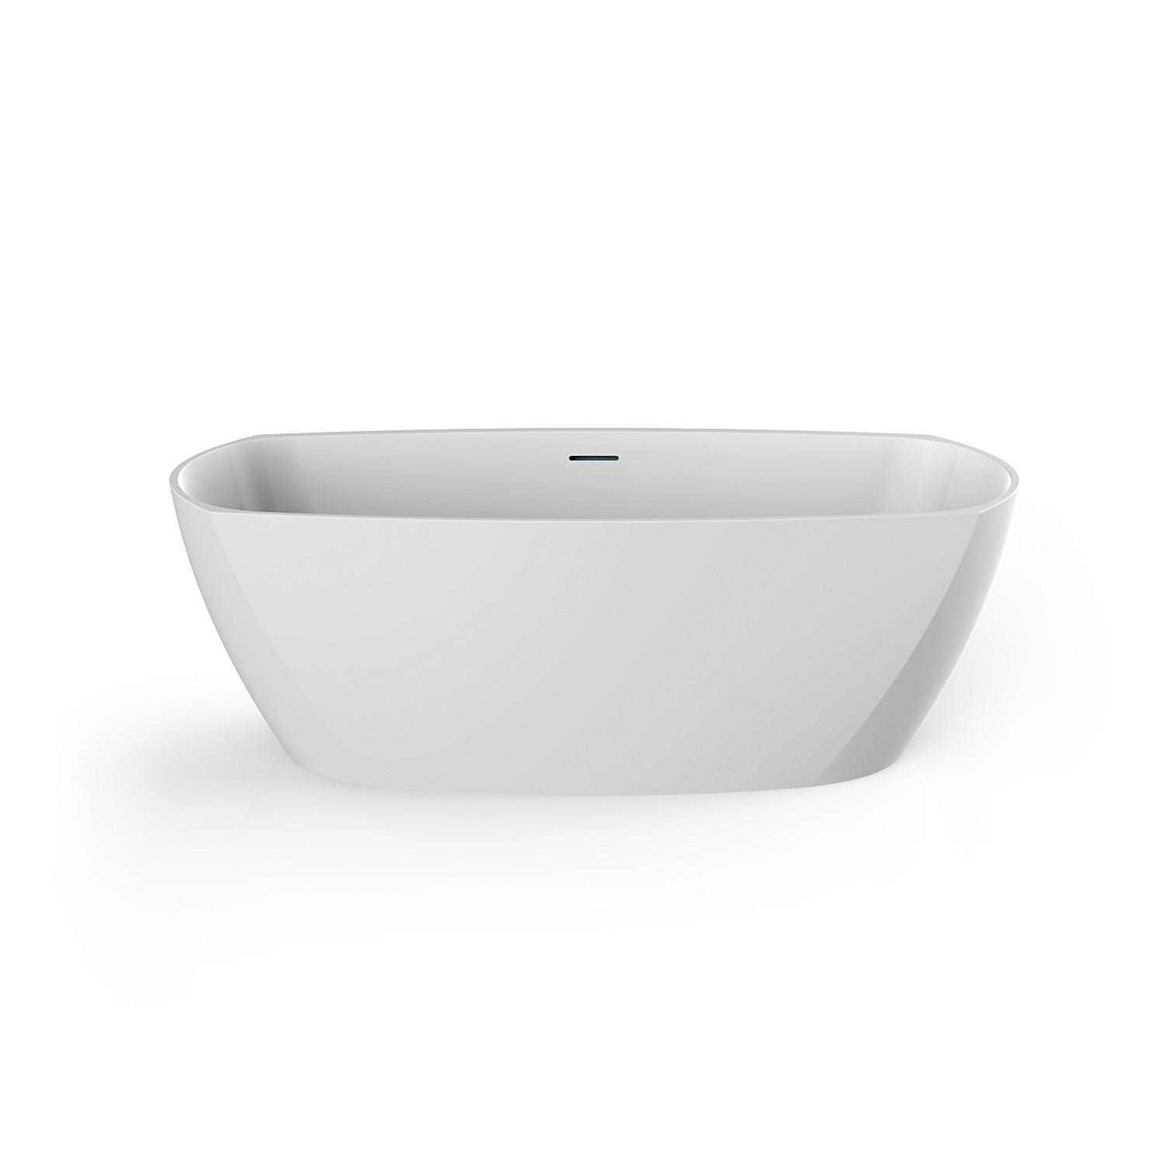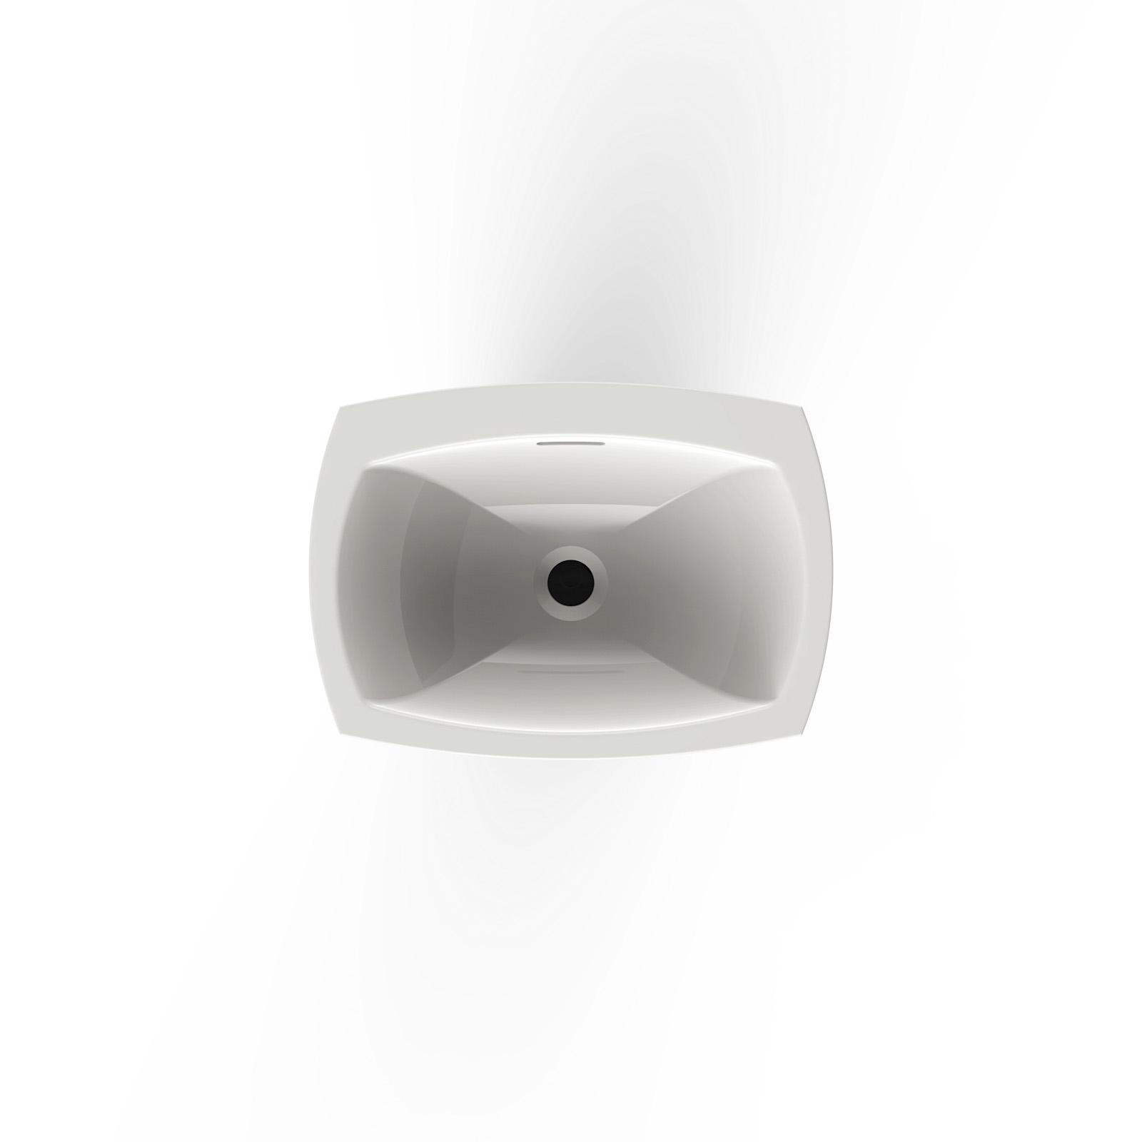
GRAFF EUROPE
Via Aretina 159, 50136 Florence - ITALY
Tel: +39 055 9332115,
fax: +39 055 9332116
email: info@graff-designs.com
www.graff-designs.com

PRESS OFFICE & DIGITAL PR

tac comunic@zione milano|genova
tel +39 02 48517618 | 0185 351616
press@taconline.it | www.taconline.it

