Press information

GRAFF Launches Innovative Sospiro Faucet Line
Faucet line to complement bar and kitchen spaces

GRAFF is honored to announce the DPHA 2017 Plumbing Product of the Year Award was awarded to our stunning Sospiro faucet! The Sospiro faucet enhances the spaces it occupies not only with a sophisticated profile, but also with elevated sanitation capabilities, separating the distribution point of hot and cold water.

The latest innovation from GRAFF®’s internal G+ Design Studio, the Sospiro Collection, offers a contemporary twist on a traditional style.
Available in both a single-hole and bridge style, Sospiro was designed with the user in mind. Pulling in the classic silhouette of a bridge faucet and pairing it with clean, sleek, curvilinear lines, the collection plays to elements popular in modern kitchens and bars.

GRAFF President and CEO, Ziggy Kulig, comments, “Sospiro’s modern design is emblematic of GRAFF’s greater style playbook, which looks to reimagine classic design concepts and produce products that are imaginative, innovative, and applicable to the needs of the customer.”

The stylish faucet is outfitted with two matching levers that can be applied to both the single-hole and bridge options. The single-hole offering is equipped with a pull-down spray head with dual spray and stream water flow functions.

Flexible in its capabilities, as well as its application, Sospiro is available for both kitchen and bar settings. Sospiro’s bar application is particularly noteworthy as it falls in line with the growing trend of in-house bars and bar stations. Taking on a slightly smaller expanse than its sister version, the Sospiro bar fixture performs instead of inhibits with its small-space design, allowing bars optimum water flow and minimalistic style that is in scale with bar sinks.

Kulig continues, “Sospiro’s design eliminates the traditional third post often associated with bridge faucets, and in turn, enhances the spaces in which it is applied through elevated sanitation capabilities and a minimalistic style that fits seamlessly into modern kitchen and bar environments.”

Sospiro is available in four stunning finishes- Polished Chrome, Brushed Nickel, Polished Nickel, and Olive Bronze - to afford designers flexibility in design.

PRICE STARTING FROM: 414,00 euros + IVA

PRESS IMAGES

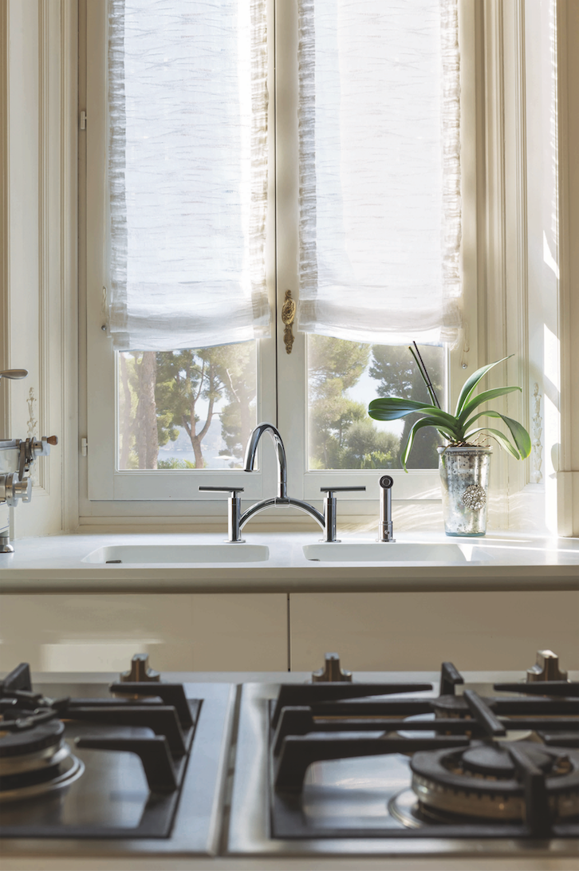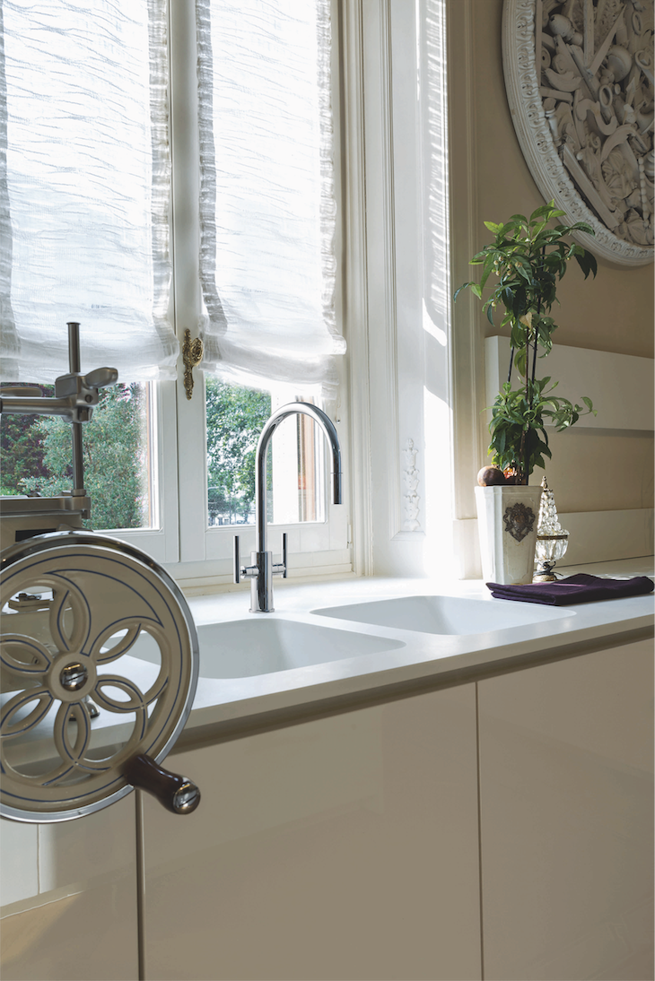
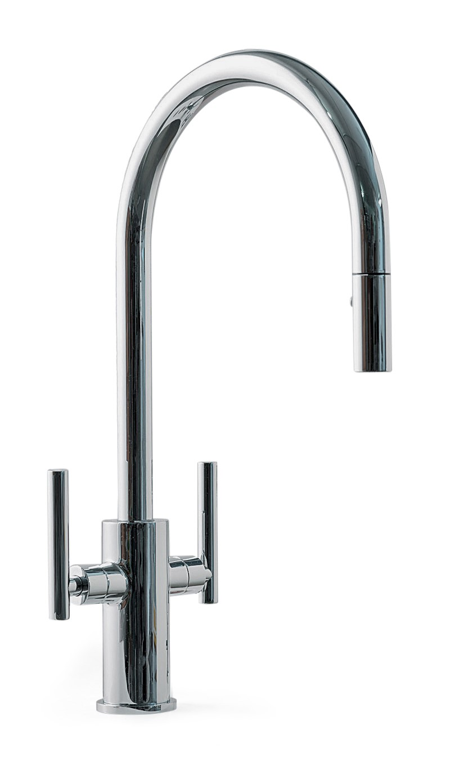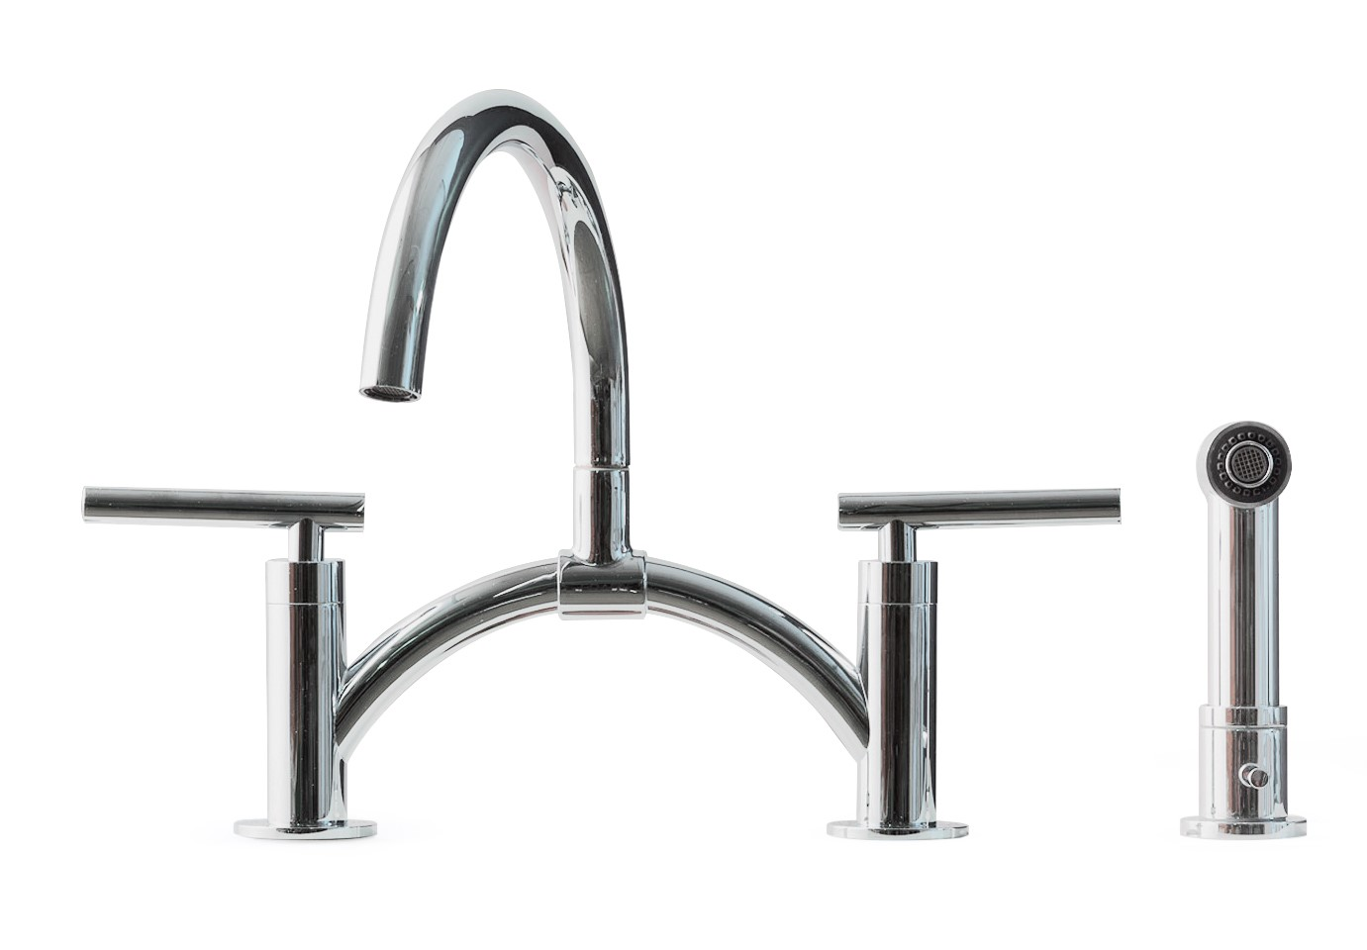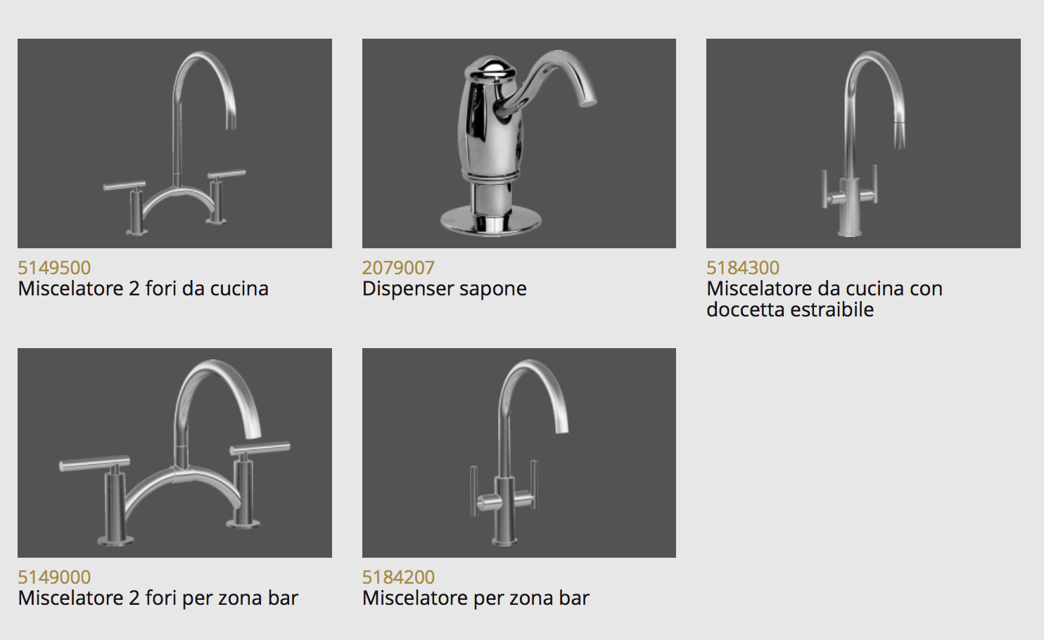
GRAFF EUROPE
Via Aretina 159, 50136 Firenze- ITALY
Tel: +39 055 9332115,
fax: +39 055 9332116
email: info@graff-mixers.com
www.graff-faucets.com

Press Office & PR
tac comunic@zione milano|genova
tel +39 02 48517618 | 0185 351616
press@taconline.it | www.taconline.it

