The Camden Collection from GRAFF in Vintage Brushed Brass is the ultimate expression of contemporary artisan tradition

MAY 2019- The Camden Collection from GRAFF is synonymous with elegance. The line of faucets and accessories for the bathroom expresses a precise stylistic presentation and a unique aesthetic language. Designed by GRAFF’s G+ Design Studio, the collection reveals itself as a key player in the larger design narrative of a project, acting as an influential piece of furniture with impact across the space. Conceived to include no superfluous details, no excessive movement, and instead a focus on traditional Edwardian style, the Camden Collection revisits a classic design in a modern key. The collection is available in the traditional version with a "cross" handle or with a "lever" handle, both functional and practical for daily use.

The Camden collection is characterized by a rhythmic aesthetic: the coordinated accessories define the environment as truly harmonic with functional furnishing elements.

All of the collection’s taps are made from a solid brass block, internally emptied. For this reason, the spout body is thicker than normal and gives the whole tap a unique importance and proportion.

In the Vintage Brushed Brass (VBB) finish, Camden expresses its best: a fresh interpretation of vintage brass with a colour ranging from yellow to dark brown. The finish is a liquid epoxy coating for a textural feel that exudes luxury. The finish offers a handmade touch, as all of GRAFF’s brushed finishes are expertly crafted by hand.

The collection is produced in brass with a very low nickel and lead content, to guarantee a long lifespan; GRAFF’s five years warranty is included. The faucet is also in compliance with drinking water regulations required for the protection of health and the environment.

The collection in Vintage Brushed Brass:

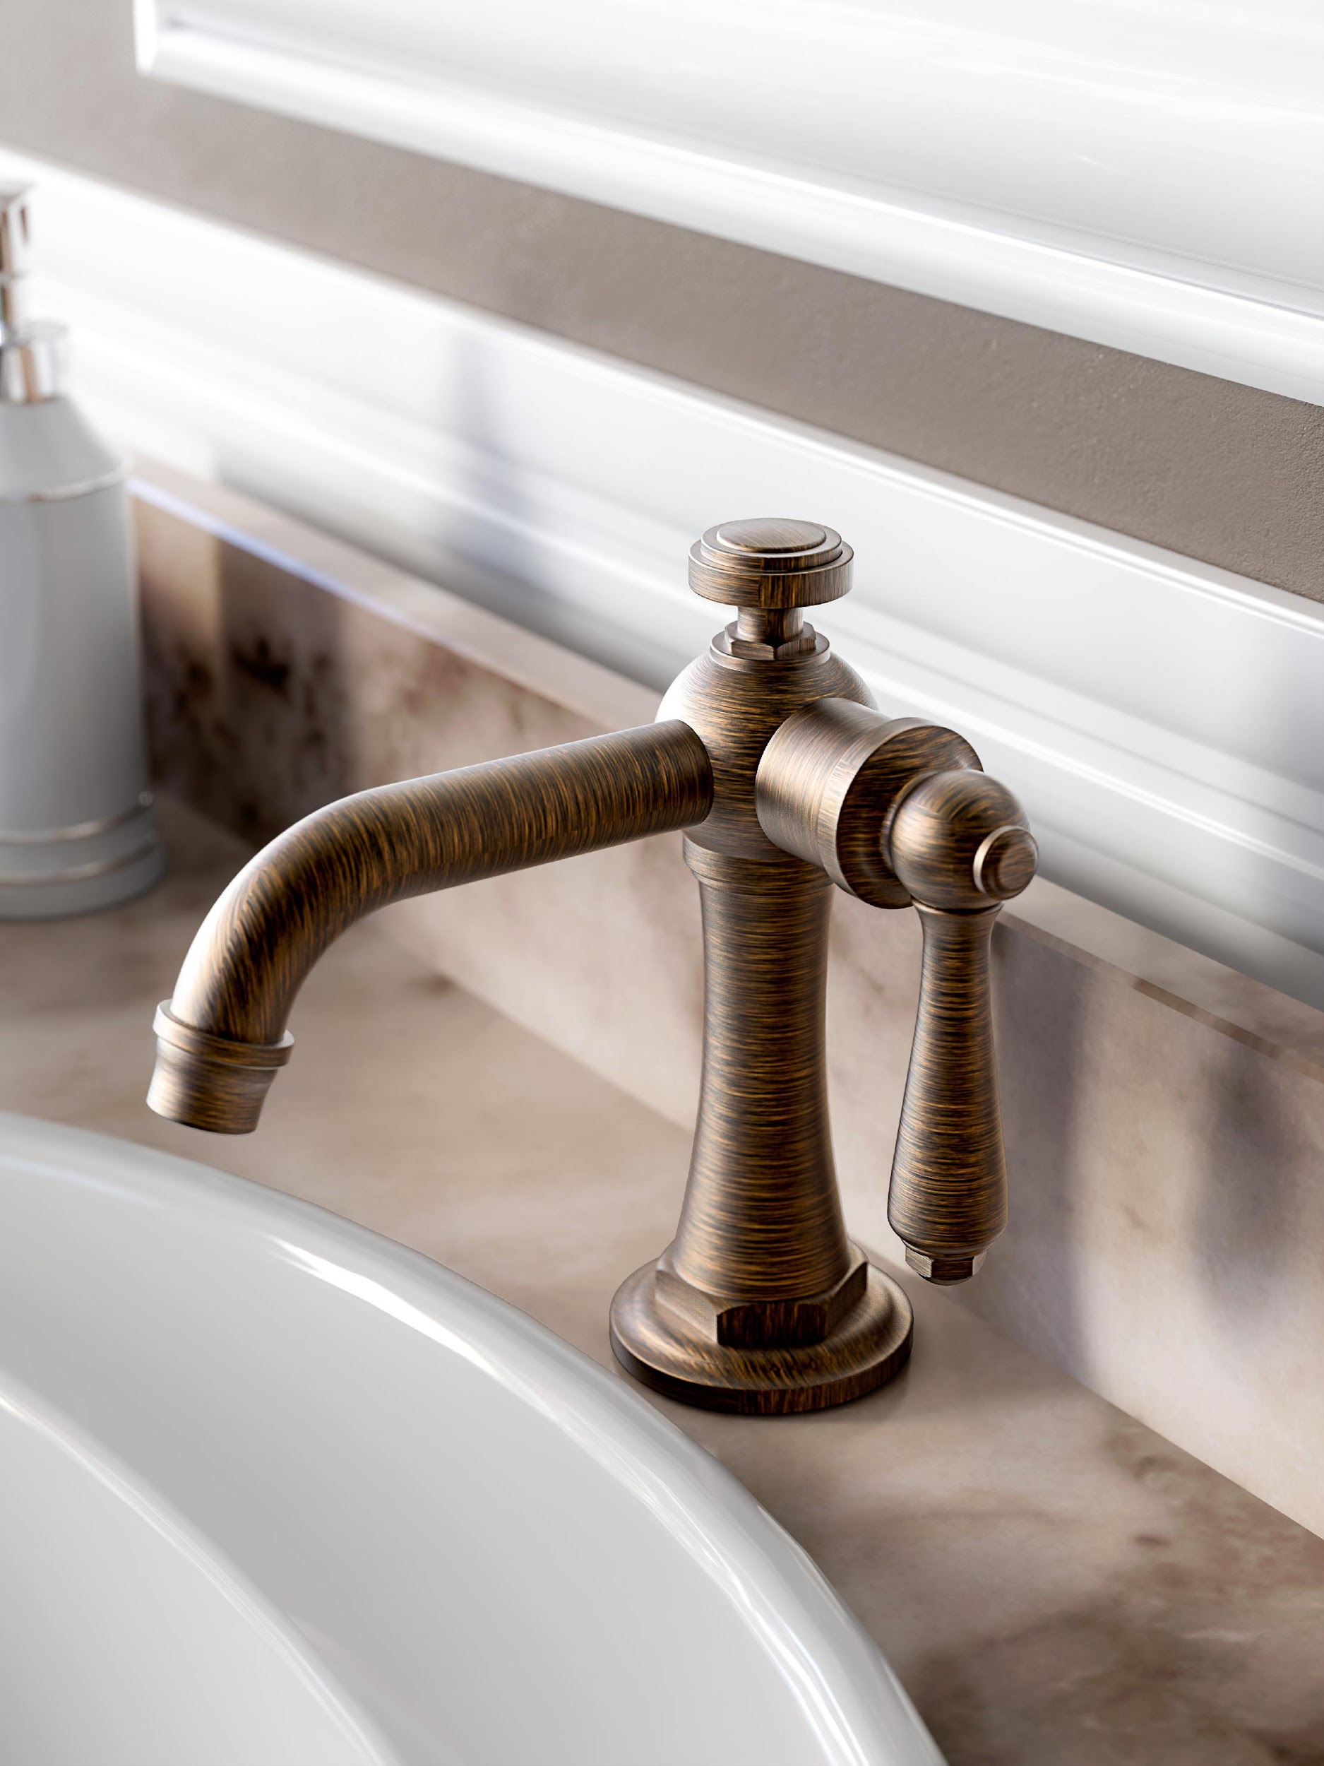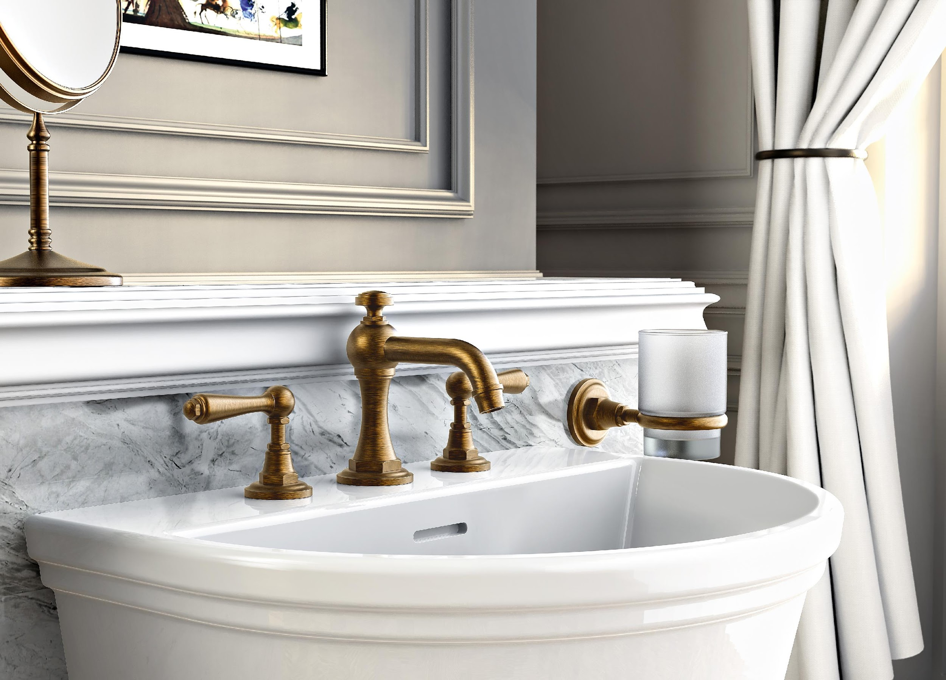
GRAFF EUROPE
Via Aretina 159, 50136 Florence - ITALY
Tel: +39 055 9332115,
fax: +39 055 9332116
email: info@graff-designs.com
www.graff-designs.com

