PLANIT AT THE SALONE DEL MOBILE

WITH CORIAN® STAGE SETS AND LIGHTS
PLANIT is back again this year, this time with a style never been seen before. The excellence of design in a capsule of the future, a mix of high-end design collaborations, plays of light, materials and high-tech processes.
The versatility of this South Tyrolean company was consolidated years ago: an expert in thermoforming DuPont™ Corian®, PLANIT has the skills to create a vast variety of forms for reception desks, walls, kitchens, bathrooms, furniture and much more.
What more could anyone want? Everything!
PLANIT is like a mechanism in perpetual motion tirelessly working to create new ideas and projects capable of shifting boundaries, opening up minds, breaking down barriers.

What, if not the Salone del Mobile 2022 and the Fuorisalone, could offer the perfect theatre for PLANIT to inaugurate new archetypes and new concepts with suggestive installations?
From Pavilion 24 Stand F02 at the Rho Fairgrounds, with an immersive and exciting new presentation of a highly awaited return in high style, to the SuperDesign Show in Via Tortona at the heart of the action during Milan Design Week with the “Fingerprint Südtirol – Alto Adige” project.
The key themes this June for PLANIT are the fruit of collaborations with Studio Oberhauser to create a concept of lights and sinuous forms, in a harmonious and exciting dance; with the designer Massimiliano Braconi to create an all-new thermoformed washbasin that achieves minimum thicknesses and extreme curves; with Mario Romano that seeks unique three-dimeionsal and backlit surfaces in Corian®.

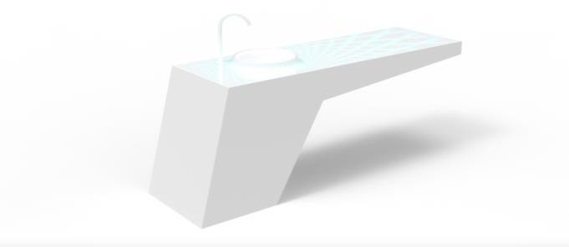

Studio Oberhauser
A new and stunning concept, visible at the Salone del Mobile Pavilion 24 Stand F02 and the SuperDesign Show in Via Tortona, as part of the “Fingerprint Südtirol – Alto Adige” project.
The representation of Martin Oberhauser’s idea takes form during design week, from continuous, modellable surfaces in Corian®, with minimal and futuristic lines, and a grid of lights moving in a harmonious symphony, to create a sensory experience.

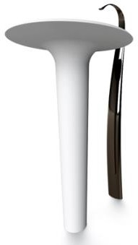

Massimiliano Braconi
This washbasin recalls the silhouette of a wasp’s thorax. Thermoformed Corian® allows for the creation of extremely minimal thicknesses and vertiginous curves, such as those of this washbasin with its articulated and hyperbolic lines. The modularity of this new product is extreme: beginning with the base, this washbasin can be defined in diverse compositions. This highly customisable approach is completed by the possibility to paint the external surface in the range of RAL colours.
There are no limits on its application: available in freestanding, top mount and built-in versions, also in custom sizes.

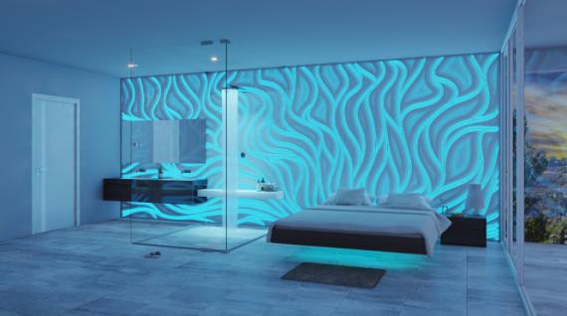

Mario Romano
The union between Mario Romano and PLANIT triggers high-tech performance. This designer’s 3D surfaces represent an innovative and high-end solution. A prototype is visible in the PLANIT stand at the Salone del Mobile, in the form of a thermoformed three-dimensional soffit that creates curved panels textured with a motif of backlit sinuous, natural lines that resemble water.

