PRESS RELEASE

LUXURY LIVING on THE Île SAINT-LOUIS, a peacuful oasis in the heart of paris

On the noble floor of a private mansion or hôtel particulier, interior designer Damien Langlois-Meurinne furnishes the bathrooms and kitchen with GRAFF

One of France’s most acclaimed interior designers, Damien Langlois-Meurinne, has earned a reputation in the industry for his remarkable designs in luxury interiors as well as furnishings. He has worked for high-profile clients including Cartier and Louis Vuitton where he designed their limited-edition Totem Floral line of accessories and furniture.

Langlois-Meurinne beautifully transformed this 17th century apartment in the Île Saint-Louis and furnished it with a diversity of design elements, blending modern and classic styles. Known for his work’s sophistication and simplicity, the French designer specially selected furnishings of the highest quality which include GRAFF bath and kitchen faucets.

The luxury residence, located on the noble floor of a formerly well-known hôtel particulier, is dominated by warm colors, and the spaces are divided by walls and mezzanines that create an intimate and inviting atmosphere.

The bathrooms in the apartment are a work of art—they are embellished with first-class GRAFF faucets and unique decorative accents. In the master bath, the console, bathtub top, and floor are all made of luxurious Panda White marble with abstract black veins that create a dramatic contrast.

Another bathroom features a wall-mounted GRAFF faucet in Olive Bronze finish which pairs beautifully with the brass accents on the bright red orange walls.

Just like how each space in the apartment has its own color scheme, the kitchen is surrounded with warm tones for a very comforting ambiance. The contemporary GRAFF Sospiro faucet stands out on the Arabescato marble countertop and complements the minimalistic kitchen.

GRAFF faucets are available in more than 20 stunning finishes, made with cutting-edge craftsmanship and with the utmost respect for environmental standards.

Photographs by Stephan Julliard

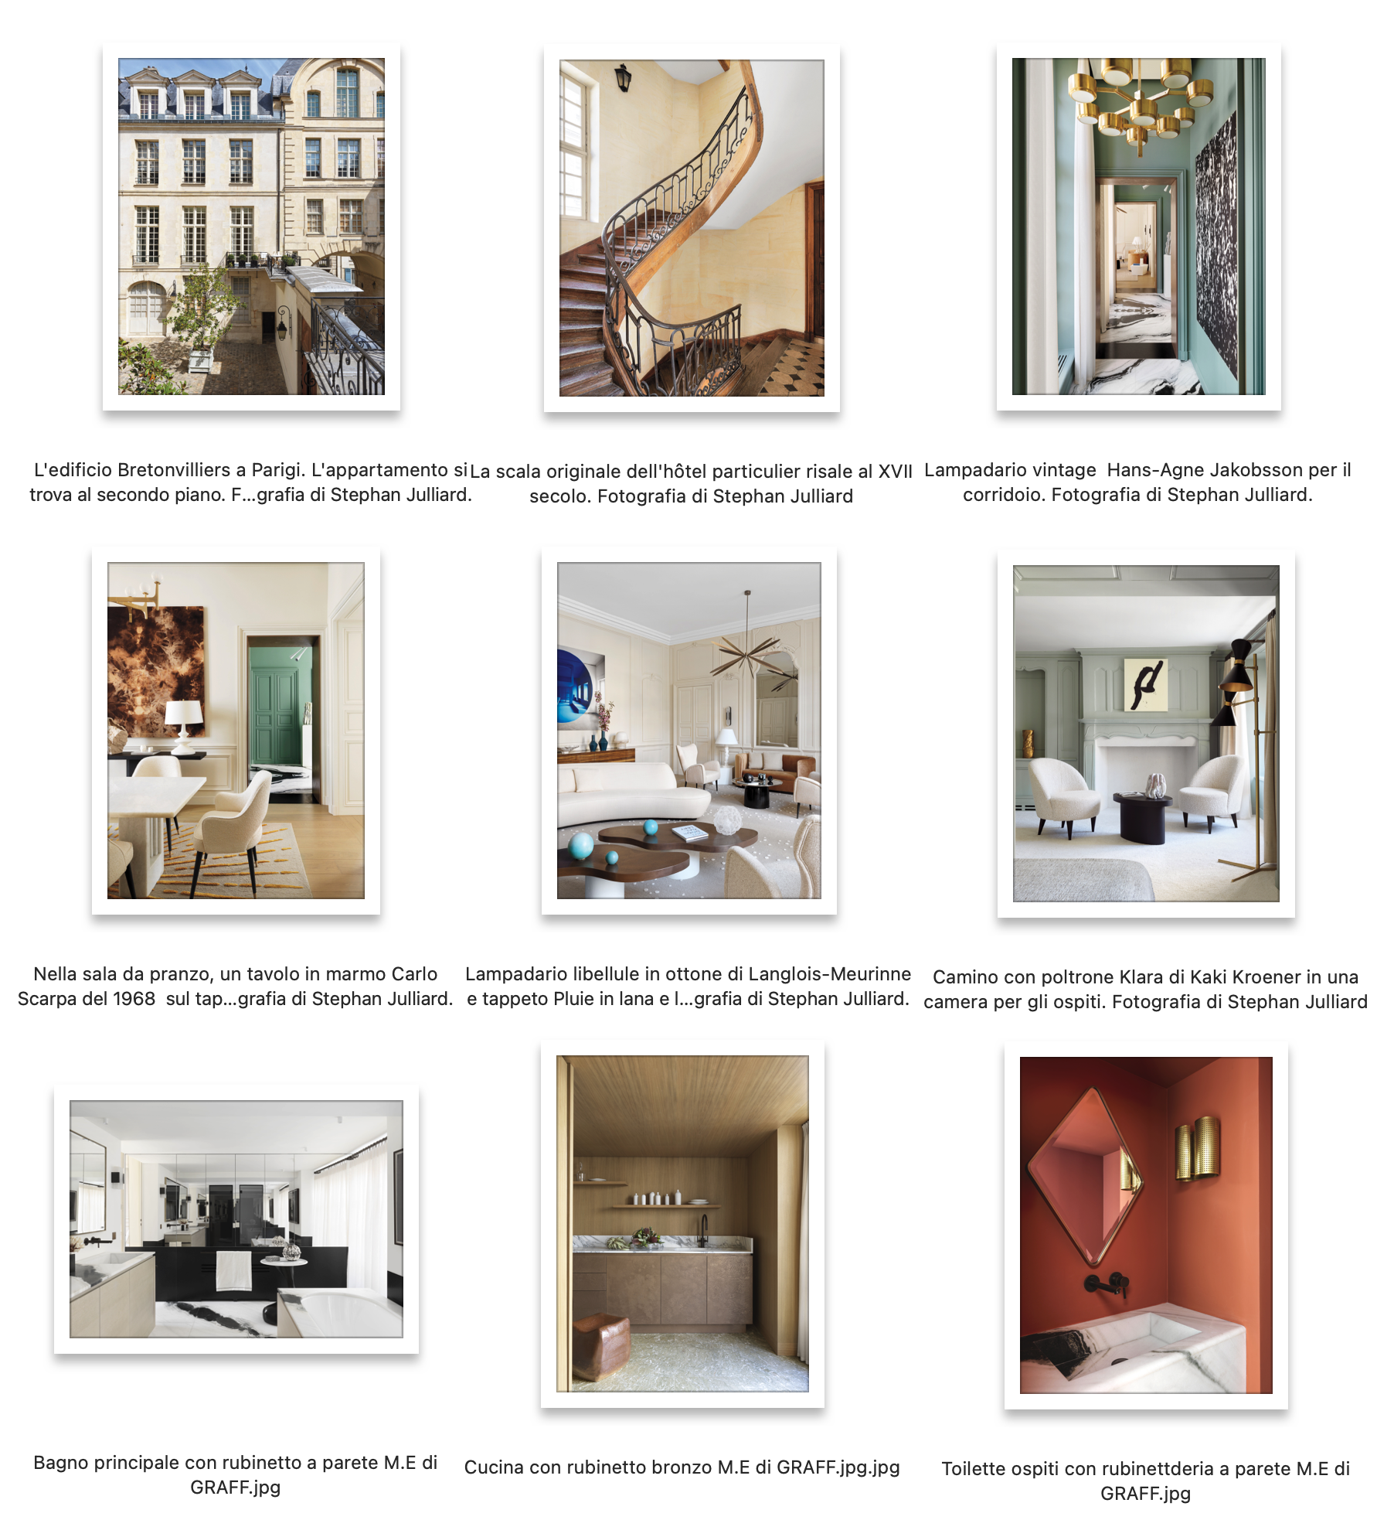
GRAFF EUROPE
Via Aretina 159, 50136 Florence - ITALY
Tel: +39 055 9332115
info@graff-designs.com | www.graff-designs.com

UFFICIO STAMPA
tac comunic@zione milano | genova
press@taconline.it | www.taconline.it

