FOR IMMEDIATE RELEASE

GRAFF® INTRODUCES NEW HARLEY COLLECTION
The collection’s design aims to revolutionize ergonomics and aesthetics in the bathroom

2018 -- GRAFF®, manufacturer of contemporary precision-engineered kitchen and bath products, is excited to unveil its stunning new Harley Faucet Collection. The design of the contemporary collection was derived from the stylings of classic motorcycles, fusing an industrial aesthetic with details nostalgic of the all-American icons.

Conceptualized by GRAFF’s G+Design Studio, the faucet’s noteworthy handle, recalling a car steering wheel, offers a unique eclecticism and adaptability to contemporary and technical environments. Each element of the faucet was carefully considered with the handle deliberately knurled to prevent slipping and prompt ease of use. An ergonomic shape serves as the basis for this design, allowing for a variety of operation techniques to be utilized. The faucet’s internal workings also create a seamless user experience, with the internal, progressive cartridge transitioning water temperature and flow rate with a simple turn of the handle, minimizing any unnecessary use of hot water.

The Harley collection includes one, two, or three-hole versions for the sink, bathtub and bidet; wall, floor or deck-mounted models, and a linear lever option, also knurled for a user-friendly handle. The free-standing bathtub filler stands out for its elegance, while the various wall-mounted faucet orientations speak to the sophistication of the collection. Additionally coordinating items intended for shower areas that are compatible with the M-series and Uni-box concealed systems are included in the collection’s offering.

The Harley collection is available in several elegant finishes, including Onyx - a PVD finish that is as attractive as it is durable. Finishes available include: Polished Chrome, Polished Nickel, Brushed Nickel, Gunmetal, Onyx, Olive Bronze, Black, White, 24K Gold and 24K Brushed Gold.

About GRAFF:
Headquartered in Milwaukee, Wis., and with locations throughout Europe, GRAFF is recognized globally for its trend-setting products and unique vision. Supported since 1922 by extensive plumbing and hardware manufacturing experience, GRAFF offers a wide range of contemporary, transitional and traditional styling. GRAFF’s commitment to creating cutting-edge, premium-quality fixtures is evident in each and every product. GRAFF employs more than 1,000 dedicated professionals and has control over the full production process, making it truly a vertically integrated manufacturer.

For more information about GRAFF, visit www.graff-designs.com or www.facebook.com/grafffaucets

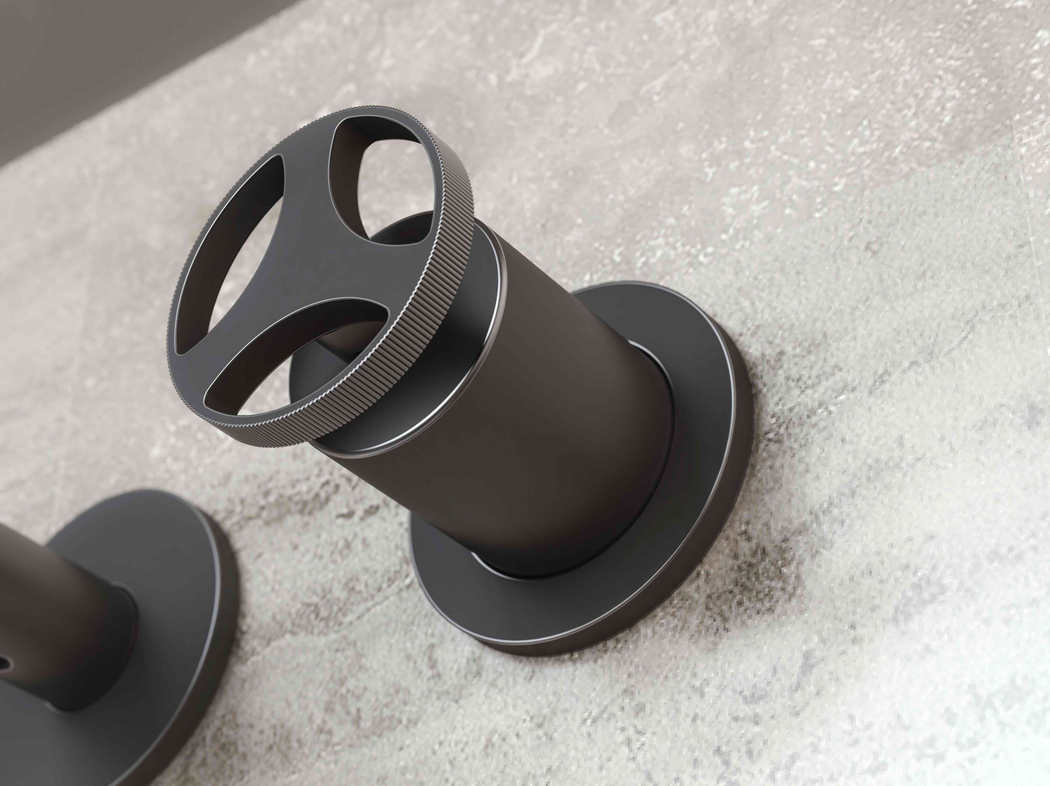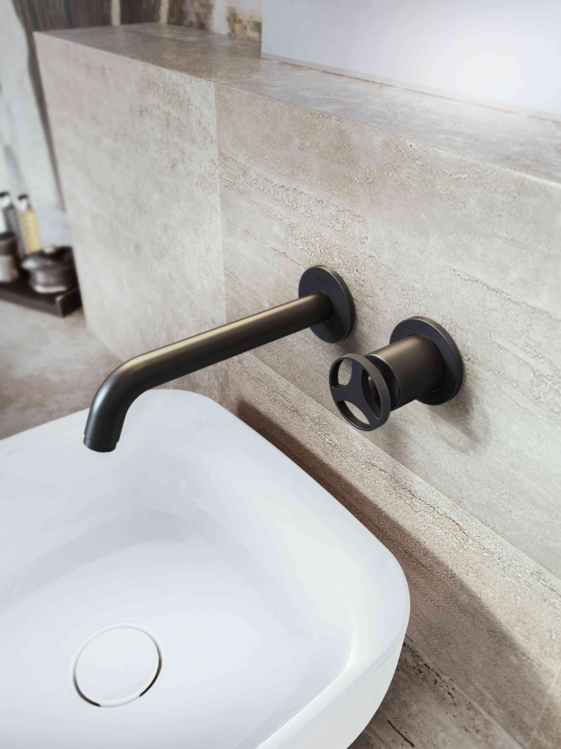

Harley, gunmetal

With a solid and appealing texture, Gunmetal is a finish with a very warm, soft to the touch feel.
The Gunmetal finish is obtained through a galvanic plating process, completed with an industrial waxing procedure.
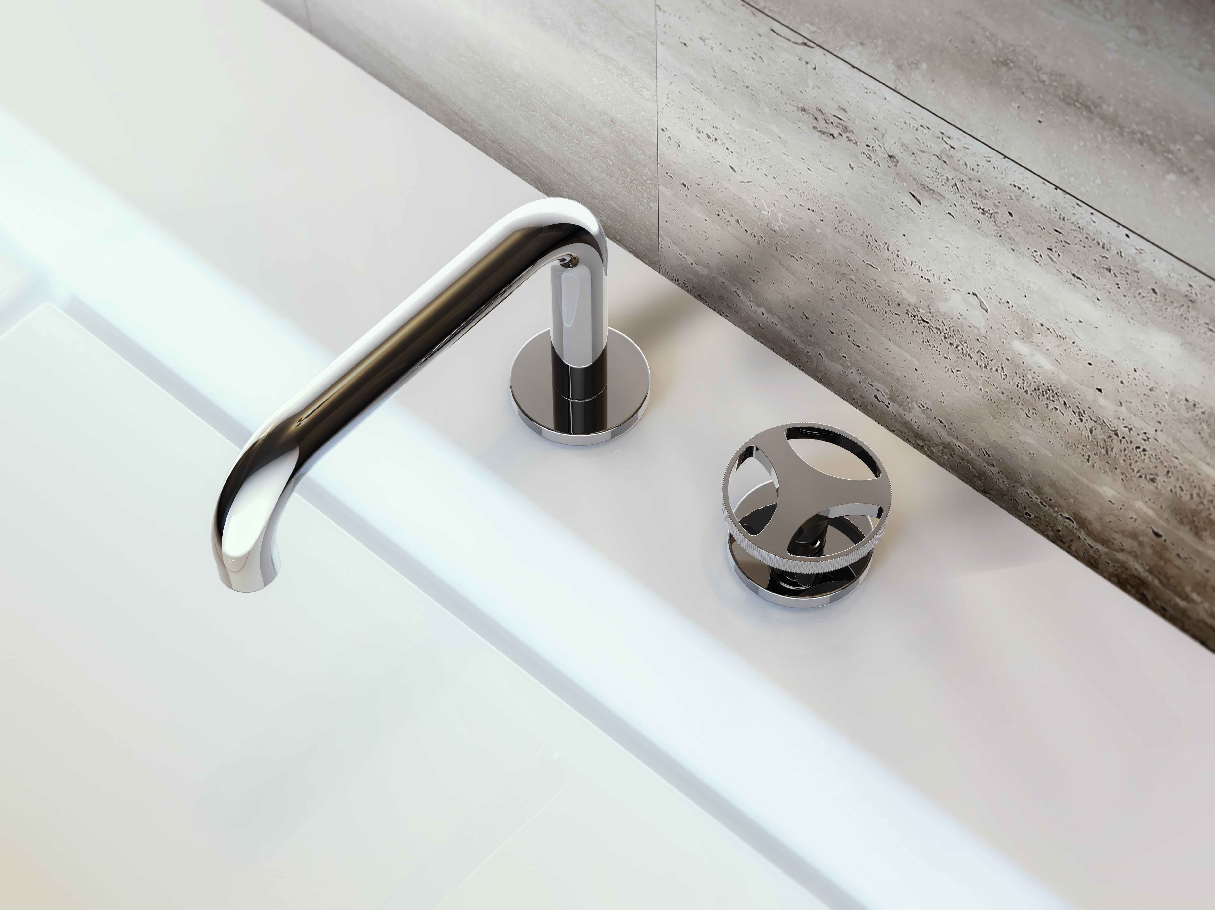

Harley polished chrome

For further information and high-resolution images
Press Release:
tac comunic@zione milano|genova
tel +39 02 48517618 | 0185 351616
press@taconline.it | www.taconline.it
GRAFF EUROPE
Via Aretina 159, 50136 Florence – ITALY
Tel: +39 055 9332115,
fax: +39 055 9332116
e-mail: info@graff-designs.com
www.graff-designs.com

